SOCHUM: The Rights of Refugees

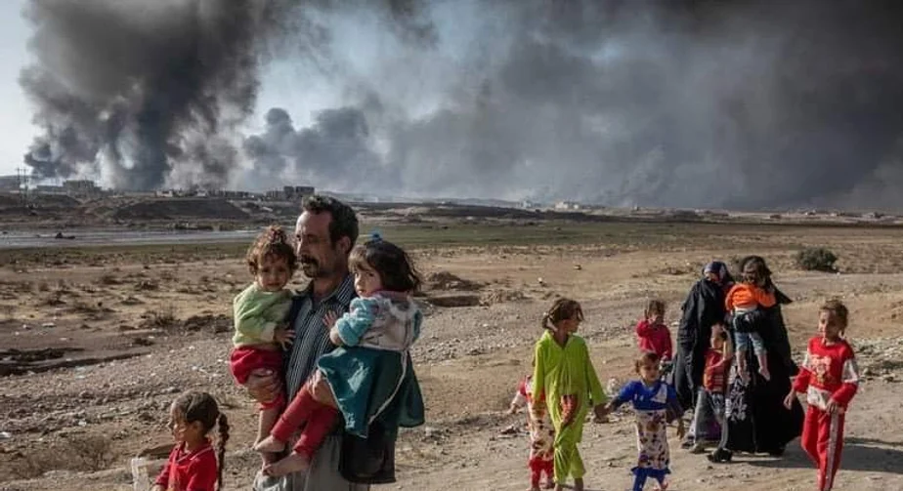

Table of Contents

Letter from the Chair ………………………………………….…………………………………. 1
Role of the Committee …………………………………..……………………...…………………2
Introduction to Refugee Policy …………………………………..……………………..................3
Current Situation …………………………………..……………………...………………….……5
Regional Case Studies ……………………..……………...………………………………...……
Case Study 1: Syria………..……………………...…………………….……………….. 7
Case Study 2: Democratic Republic of the Congo..…………………….……………….. 8
Questions to Consider …………………………………..…….………………...…………………9
References …………………………………..…………………….…...…………………….…....10

Esteemed delegates,

It is my honor to welcome you to ClarkMUN XIII. I am overjoyed to see ClarkMUN return once again in person as we recover from the disruptions caused by the COVID-19 pandemic. This year’s conference is set to provide a myriad of topics for debate, and it is my pleasure to serve as your Chair for the SOCHUM committee. This is my third ClarkMUN, having served in the past on the Secretariat as Director of Outreach, and having chaired DISEC and Warren G. Harding’s Presidential Cabinet. I am a junior double majoring in Political Science and Genocide Studies, with research interests in ethnic violence in the African Great Lakes Region as well as contemporary Rwandan Politics. I was born and raised in Düsseldorf, Germany, and spent some years in Maine to complete my high school education. I now call Worcester my home and am excited to welcome you to Clark in March.

Involvement in Model UN has transformed my college experience. I serve on the Executive Board of our travel delegation team as Treasurer. We compete in 10 conferences annually, which provides invaluable opportunities to network with other students, develop skills, and learn about all topics of international law. I am a General Assembly delegate at heart and am beyond excited to see this SOCHUM committee come to fruition. Outside of MUN, I can be found watching the Premier League (go Gunners!), finding the newest political drama on Netflix, or spending time with my friends at local Worcester restaurants.

The topic at hand encapsulates the intersection of many human rights considerations which impact one of the most vulnerable populations worldwide: refugees. Refugee rights have become a contentious debate among politicians worldwide, and policymakers have lost focus on the importance of prioritizing human rights above economic or political gain. My hope for you is to dive into creative solutions to address the issue while maintaining clear understanding of your country’s unique contributions to international discourse.

The dais will be looking for delegates who focus on diplomacy, collaboration, and development of comprehensive and sustainable solutions when considering awards. It is my absolute pleasure to be chairing this committee, and I look forward to meeting all of you!

If you have any questions, comments, or concerns, please do not hesitate to contact me at zellingwood@clarku.edu.

Kindest regards,
Zoe Ellingwood

Role of Committee

The Social, Humanitarian, and Cultural Issues (SOCHUM) Committee is the Third Committee of the United Nations General Assembly and was established in 1945. It was founded in reaction to the Universal Declaration on Human Rights. The SOCHUM committee focuses on issues dealing with fundamental human rights within the international community. It is enshrined within the United Nations Charter to design and implement recommendations for promoting universal fundamental rights for all. The Third Committee meets annually, including representatives of all United Nations members, to address a variety of topics from September to November. Most recently, the 2022 session addressed social development, information and technologies, racism, self-determination, and the rights of women and children. It also drafted three resolutions on the recommendations to the UN Refugee Agency, as it oversees the activities of and progress made by the UNHCR. This committee will take place in the present, and delegates should research past resolutions drafted by past SOCHUM iterations in regard to the UNHCR. Furthermore, delegates should consider the shortcomings within past resolutions and draft creative adjustments to circumvent those barriers.

The role of this committee is to address the human rights of refugees globally. Moreso, delegates are tasked with the implications that refugee populations have on host communities as well as the unequal division of responsibility that states play in hosting refugees. As delegates representing countries from all regions of the world, you will be tasked with making policy recommendations to the UNHCR on behalf of the Third Committee. Importance will be placed on maintaining your country’s policies while also designing applicable solutions to other regions. You will be collaborating to draft resolutions with other delegates, so keep in mind to research your country’s unique contributions.

The committee will follow a traditional General Assembly format. We will begin with opening a Speaker’s List, where delegates will introduce themselves and announce their country’s positioning and specific goals for the committee. We will then transition to moderated and unmoderated caucuses, where delegates can elaborate on specific topics and form blocs of like-minded delegates. Drafting Working Papers with your blocs will solidify those ideas, as you present them to the committee later in the day. By the end of the conference, the dais will be looking for merged Draft Resolutions that finalize your recommendations to the UNHCR in the 2023 Session of the SOCHUM Committee.

Introduction to Refugee Policy

The Refugee Crisis is one of the most pressing concerns of the 21st Century. It is estimated that over 84 million people worldwide have been displaced from their homes. Among this daunting number are 32.5 million refugees. This number is only growing due to political instability, economic concerns, cyclical violence, climate disasters, and unaddressed historical disputes. Refugees have been defined by the United Nations as “persons fleeing armed conflict or persecution” and differ from the frequently used term migrant. Migrants differ from refugees in their circumstances that led to their displacement. Rather than fleeing due to lack of safety or stability, migrants aim to flee in effort to better their living conditions or unite with family. Countries have separate proceedings for refugees and migrants. Migrants fall under domestic immigration laws and processes, which the United Nations has no power to impede upon, while refugee policy is widely guided by international norms and law. Additionally, refugees require a much more pressing increase of assistance because of the violent nature of their migration. Serious consequences can arise as a result of conflating the two terms. Therefore, this committee will focus on refugee policy specifically.

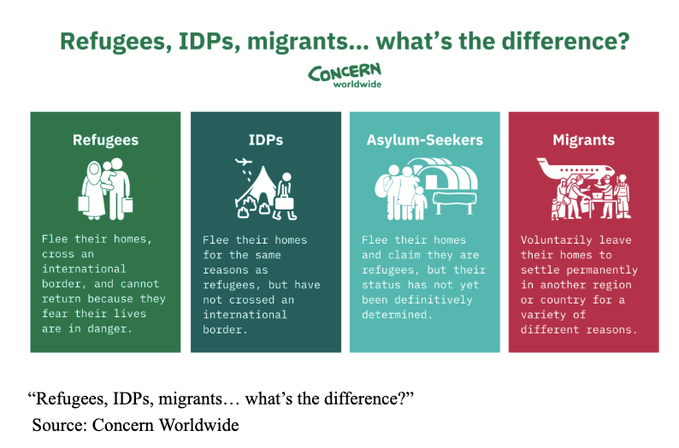
It is important to note that not all forcibly displaced persons are refugees. Many of those fleeing their home due to violence remain within the borders of their country. These are called Internally Displaced Persons or IDPs. IDPs make up a larger proportion of displaced persons globally, and face many of the same challenges as refugees. However, they are not granted the same rights as refugees under international law as the term IDP is a descriptive one rather than a legal one. Furthermore, refugees receive their status upon application for asylum in their host country. The term “asylum seeker” includes those fleeing their home countries seeking international protection in a host country. It is important to consider that the term “refugee” is not all-encompassing and delegates’ proposed policies within this committee should make effort to apply to IDPs and asylum seekers, as well.

Following the Cold War, an international emphasis on humanitarianism came about. Humanitarianism is generally defined as “impartial, neutral, and independent provisions of relief to victims of conflict and natural disasters” and is rooted in 19th century European History. The international order saw humanitarianism as a focal aspect of achieving state, regional, and global security, and due to the rising concern of displacement due to violent conflict, refugee policy was formed. The 1951 Refugee Convention and its following 1967 Protocol layed the legal groundwork for UN practices on refugees, including the establishment of the UNHCR. The UNHCR first took form in assisting in the decolonization of Africa, reconstruction after the Balkan Wars, as well as in Asia and Latin America, and now operates in 132 countries. Its headquarters is located in Geneva, Switzerland, and employs roughly 18,000 individuals worldwide, which are reported to be assisting over 59 million refugees worldwide today. Most refugees are positioned within Africa and Asia, where a majority of the world’s refugees originate from and locate to. Functioning under the UN General Assembly SOCHUM, the UNHCR makes up a majority of humanitarian assistance programs that benefit refugees today. Additionally, SOCHUM oversees other organizations such as the United Nations Relief and Works Agency for Palenstine Refugees in the Near East (UNRWA) which similarly assists refugees in the Gaza Strip, West Bank, and East Jerusalem.

The primary objective of the SOCHUM committee is to evaluate the historical implementations of the 1951 Refugee Convention, to determine its shortcomings, and to recommend improvements in policy objectives. Delegates are welcome to propose amendments to the Convention, as well as the development of new initiatives that could be adopted by the UNHCR to improve refugee settlement mechanisms.

Current Situation

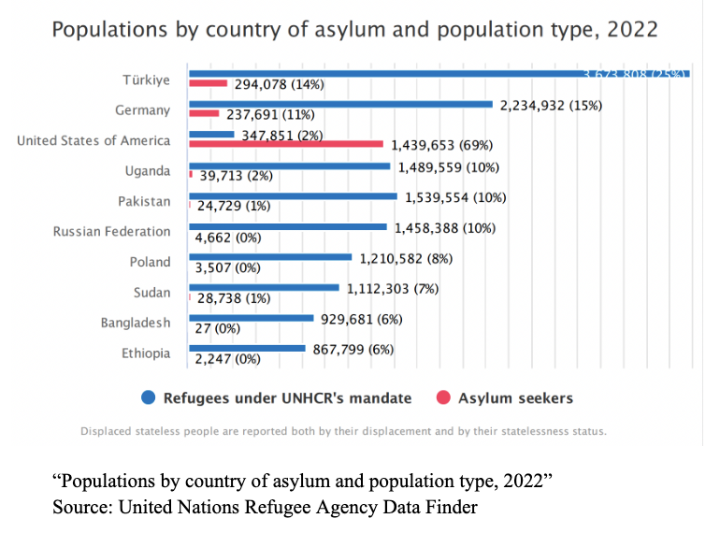
Origin and Host Countries

The nature of displacement has been transformed in the past decade due to increased globalization. With the increased access to technology and transportation, people are more easily able to travel away from regions of high conflict and violence. However, more than 70% of refugees under the UNHCR mandate originate from only five countries: Syria, Venezuela, Ukraine, Afghanistan, and South Sudan.

The primary problem surrounding refugee policy lies with the will of countries to host them. 74% of the world’s refugees are hosted in low- and middle-income countries, and LDCs provide asylum to 22% of the total. Refugees tend to flee to surrounding countries for safety, with 70% of refugees reported fleeing to neighboring countries. The UNHCR reports that 36% of all refugees are hosted in five countries: Turkey, Colombia, Germany, Pakistan, and Uganda.

Burden-Sharing

With these statistics in mind, a few trends are present. Firstly, the most developed states in the world do not contribute to resettlement effectively. Burden sharing is an established principle established within the 1951 Convention. The preamble notes that granting asylum "may place unduly heavy burdens on certain countries," therefore promoting international cooperation to lessen this burden on host countries that lack the capacity to effectively manage an influx of refugees. This burden-sharing presents itself in two ways: financial and physical. Financial burden-sharing can be seen through UN member states’ contributions to organizations such as the UNHCR, and through funding non-governmental organizations. Physical burden-sharing includes the actual acceptance and resettlement of asylum seekers. Typically, physical burden-sharing is seen as the more proactive strategy in international cooperation. The European Union provides an example of international cooperation. In 1994, Germany proposed a system of physical dispersal of refugees in which EU member states share responsibility of resettlement based on territory, population, and GDP. This would allow countries to host refugees in proportion to their capacity, and create an equitable system of burden-sharing. However, this program was rejected due to sociopolitical concerns.

More recent proposals have included the development of internationally protected areas (IPAs) in regions of origin which would establish safe havens for asylum seekers before they reach their host country. The United Kingdom, for example, pushed for funding transit camps to accommodate asylum applications from the Balkans or Ukraine. Critics of these programs, however, argue that these areas cannot ensure safety and exacerbate the burden placed on neighboring countries which host these IPAs. Proposals such as these off-load the responsibility onto countries with inadequate resources.

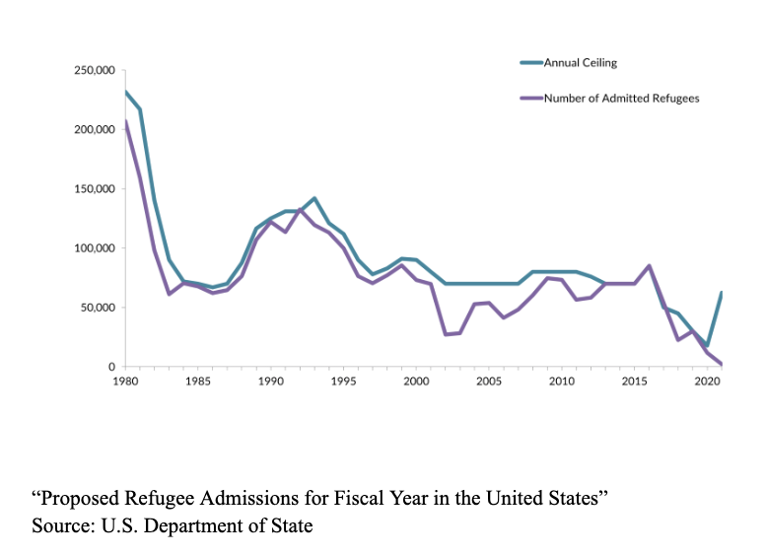
Political implications furthermore play a role in refugee policies. The United States, for example, has seen a drastic change in its refugee admission ceiling in the past two decades. In 1993, as a result of the Balkan Wars, the country accepted 142,000 refugees. Since then, it has steadily declined. From 1999 to 2016, the ceiling ranged between 70,000 and 91,000 admittances. In 2017, this number rose to 110,000 people. The Trump Administration decreased this number significantly. The cap was decreased from 110,000 people to only 50,000 people and the Administration even halted applications from 11 countries, a majority of them holding a Muslim-majority. Most drastically, in 2020 only 12,000 refugees were resettled. Although the Biden Administration seeks to reverse this policy, most notably by raising the ceiling to 125,000 people in 2023, the damage done by previous years is evident.

The United States, as well as other high-income countries, clearly have the capacity to take on more of the burden of refugee resettlement. Delegates are encouraged to find solutions to this imbalance.

Regional Case Studies

The Syrian Refugee Crisis

The Syrian Refugee Crisis is of major concern to the United Nations. 14.6 million people are in need of humanitarian assistance, including 6.7 million IDPs and 6.6 million which are hosted in other surrounding countries. Syria is entering its 11th year of crisis, and the need for intervention for refugees escalates every year. The UNHCR has been working on the ground in Syria since the outbreak of the crisis, and focuses primarily on emergency aid, providing immediate life-saving medical assistance, environmental protection, and the establishment of designated safe camps in Za‘atari and Azraq. However, most refugees flee to neighboring countries and live in urban and rural settings in surrounding countries, often in poverty.

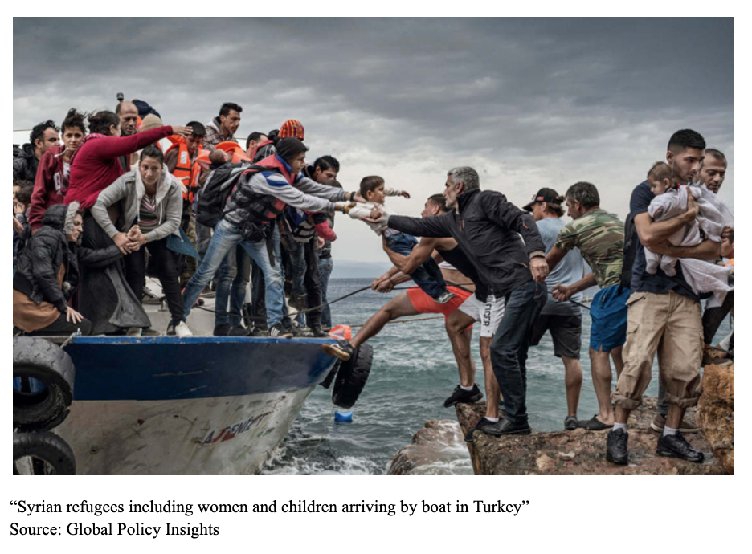
The Syrian refugee crisis indicated that a reform was needed: rather than traditional resettlement and disaster mitigation, resilience and infrastructure strengthening is required. Surrounding countries are struggling to both accommodate the influx of refugees as well as integrating them into local communities and economies. The UNHCR provides a multitude of avenues for assistance through the Regional Refugee and Resilience Plan, which aims to assist Syrian communities in the diaspora. It strengthens national and local systems through alleviating the barriers needed to host communities. Some of these examples include providing cash grants to cover education and legal expenses, assisting in job placement, and providing funding to existing institutions that provide humanitarian assistance.

Refugee policy in Syria displays two fundamental concerns: the consequences of failure to address conflict at its root, and the need for long-term sustainable solutions. Both are underpinned by the lack of active involvement of actors that have the capacity to enact meaningful change. Delegates are encouraged to keep these in mind when designing policies.

Democratic Republic of the Congo

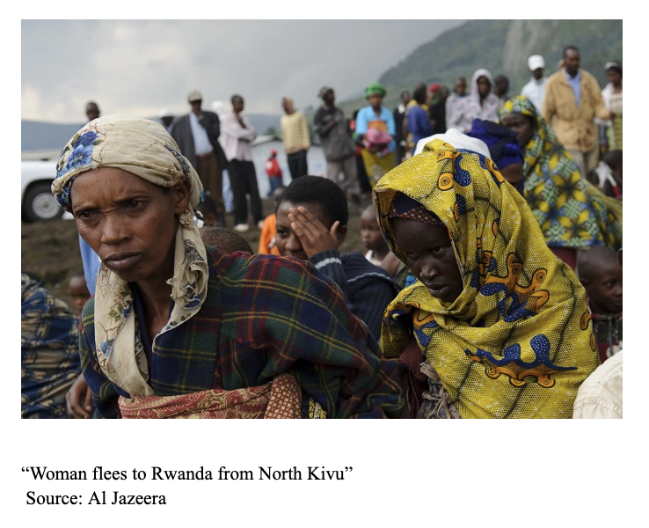
The Democratic Republic of the Congo (DRC) hosts a half-million refugees as well as five million internally displaced people. It has one of the most complex histories of violence in the world, with 60 years of ethnic conflict resulting in cyclical patterns of displacement. This is only exacerbated by natural disasters and disease outbreaks. The UNHCR currently leads the Regional Refugee Response Plan (RRRP) in the DR Congo which serves to provide a multilateral, cooperative forum for international organizations to address the humanitarian crisis within the region. Additionally, Congolese refugees are found among the African continent, as well. The 2022 UNHCR DRC Regional Refugee Response Plan reports that over one million people are refugees and asylum-seekers in Angola, Burundi, Republic of the Congo, Rwanda, Uganda, Tanzania and Zambia. Most of these refugees are reported to have fled from the eastern areas of North and South Kivu and the Ituri Provinces. The most notable problem facing this region is unaddressed historical conflict that is perpetuated by minority groups and the Congolese army alike. Due to an overwhelming number of displaced persons which saturates host communities beyond capacities, coupled with lack of progress in addressing the roots for displacement, the situation is dire and the trajectory for resolve is poor.

The UNHCR has four main strategic priorities including protection, multi-sector assistance, self-reliance, social cohesion, and durable solutions. All four are meant to facilitate collaborations with other non-governmental relief organizations working within the DRC. Protection focuses on the legal status ensured for all refugees and asylum seekers, by partnering with relevant government stakeholders. Multi-sector assistance focuses on emergency assistance for new arrivals as well as longer-term solutions. Self-reliance strengthens both non-reliance on assistance as well as relations with host communities. Durable solutions further aim to mitigate suffering through projects aimed at repatriation and sustainable resettlement. Through this four-step approach, the UNHCR aims to coordinate long-term relief efforts for refugees at all levels of need, from root causes to emergency assistance to long-term settlement or the eventual goal of returning home.

Humanitarian assistance for the DRC faced several barriers. Cyclical violence continues because of unaddressed historical oppression and ethnic conflict, leading to constant displacement of communities as violence continues to escalate. This leads to mass amounts of migration to neighboring countries. However, the surrounding countries also experience similar cycles of violence, thus unequipped to manage the influx of people due to their own instability. General consensus regarding the DRC case remains to contain relief efforts regionally, but this approach has not succeeded in containing the problem at hand.

Questions to Consider

- What barriers face the effectiveness of the 1951 Refugee Convention? What amendments can be proposed to alleviate these barriers?
- What can be learned from existing effective refugee policies? How can those measures be utilized in other regions?
- Should all countries be mandated to assist in refugee resettlement? To what extent, if so?
- The Mediterranean Sea is regarded as Europe’s Largest Graveyard. Why is this so? What can be done to ensure safe passage for refugees to reach their host countries?
- How can the international community collaborate to develop effective burden-sharing mechanisms? What incentives can be given to high-income nations to take a more active role in refugee settlement?
- Each country faces varying circumstances that lead to forced displacement. Should policy attempt to universalize refugee policy, or should regional considerations be taken into account?
- Many high-income nations are reluctant to take a more active role in refugee settlement because the topic has been politically polarized. What steps can be taken to change this?

References

Boswell, Christina. “Burden-Sharing in the New Age of Immigration.” Migration Policy
Institute, 1 November 2003,
https://www.migrationpolicy.org/article/burden-sharing-new-age-immigration,

Center for Preventive Action. “Instability in the Democratic Republic of Congo.” Global
Conflict Tracker, 3 August, 2022,
https://www.cfr.org/global-conflict-tracker/conflict/violence-democratic-republic-congo

“Classifying Refugee Host Countries by Income Level.” UNHCR,
https://www.unhcr.org/refugee-statistics/insights/explainers/refugee-host-countries-incom
e-level.html

“Draft Provisional Programme of Work of the Third Committee - 77th Session.” United Nations
General Assembly, https://www.un.org/en/ga/third/77/docs/calendar.pdf

Edwards, Adrian. “UNHCR Viewpoint: ‘Refugee’ or ‘Migrant’ Which is Right?” UNHCR USA,
11 July, 2016,
https://www.unhcr.org/news/latest/2016/7/55df0e556/unhcr-viewpoint-refugee-migrant-right.html

Gabiam, Nell. “Humanitarianism, Development, and Security in the 21st Century: Lessons from
the Syrian Refugee Crisis.” International Journal of Middle East Studies, vol. 48, no. 2,
2016, pp. 382–86. JSTOR, http://www.jstor.org/stable/43998127

McIntyre, Heather. “A Comparative Analysis of Key Structures & Responses to the Syrian
Refugee Crisis
in Germany, Turkey, and the United States.” Global Policy Insights, 3 January 2020,
https://globalpolicyinsights.org/analysis-of-key-structures.php

Monin, Kira. “Refugees and Asylees in the United States.” Migration Policy Institute, 13 May, 2021,
https://www.migrationpolicy.org/article/refugees-and-asylees-united-states?gclid=Cj0KC
QiAiJSeBhCCARIsAHnAzT9yypjK7odLRwGVW2O9ZP2I76jc9rQLUiUE4lEZ1B8e0E
gjjhlqwfkaAoAREALw_wcB

Moore, Phil. “In Pictures: DR Congo Crisis.” Al Jazeera, 20 May 2012,
https://www.aljazeera.com/gallery/2012/5/20/in-pictures-dr-congo-crisis

“Proposed Refugee Admissions for Fiscal Year.” Migration Policy Institute, 202.
https://www.migrationpolicy.org/programs/data-hub/charts/us-refugee-resettlement

“Refugee Data Finder.” UNHCR, 15 January, 2023, https://www.unhcr.org/refugee-statistics/

“Refugees.” United Nations, United Nations, https://www.un.org/en/global-issues/refugees.

“Refugee vs. IDP vs. Migrant… What’s the Difference?” Concern Worldwide, 8 April, 2022,
https://www.concernusa.org/story/refugee-idp-migrant-difference/

“Social, Humanitarian & Cultural Issues (Third Committee).” United Nations General Assembly, https://www.un.org/en/ga/third/

“Syria Refugee Crisis Explained.” How to Help Refugees - Aid, Relief and Donations,
https://www.unrefugees.org/news/syria-refugee-crisis-explained/.

“The 10 Largest Refugee Crises to Know in 2023.” Concern Worldwide, 13 January 2023,
https://www.concernusa.org/story/largest-refugee-crises/

“UNHCR - Additional Partnerships.” UNHCR- United Nations Refugee Agency,
https://www.unhcr.org/partnerships.html.

United Nations High Commissioner for Refugees. “DR Congo Emergency.” UNHCR, UNHCR,
The UN Refugee Agency, https://www.unhcr.org/dr-congo-emergency.html.

United Nations Refugee Agency. DRC RRRRP Report, 2022
https://reporting.unhcr.org/document/2912

United Nations High Commissioner for Refugees. “Syria Emergency.” UNHCR, UNHCR, The
UN Refugee Agency, https://www.unhcr.org/syria-emergency.html.

“U.S. Annual Refugee Resettlement Ceilings and Number of Refugees Admitted, 1980-Present”
Migration Policy Institute,
https://www.migrationpolicy.org/programs/data-hub/charts/us-refugee-resettlement

“Draft Provisional Programme of Work of the Third Committee - 77th Session.” United Nations General Assembly,
“Social, Humanitarian & Cultural Issues (Third Committee).” United Nations General Assembly,
“The 10 Largest Refugee Crises to Know in 2023.” Concern Worldwide, 13 January 2023,
Edwards, Adrian. “UNHCR Viewpoint: ‘Refugee’ or ‘Migrant’ Which is Right?” UNHCR USA, 11 July, 2016,
Gabiam, Nell. “Humanitarianism, Development, and Security in the 21st Century: Lessons from the Syrian Refugee Crisis.” International Journal of Middle East Studies, vol. 48, no. 2, 2016, pp. 382–86. JSTOR,
“Refugees.” United Nations, United Nations,
“UNHCR - Additional Partnerships.” UNHCR- United Nations Refugee Agency,
“Refugee vs. IDP vs. Migrant… What’s the Difference?” Concern Worldwide, 8 April, 2022,
“Refugee Data Finder.” UNHCR, 15 January, 2023,
“Refugee Data Finder.” UNHCR, 15 January, 2023,
“Classifying Refugee Host Countries by Income Level.” UNHCR,
Boswell, Christina. “Burden-Sharing in the New Age of Immigration.” Migration Policy Institute, 1 November 2003,
Monin, Kira. “Refugees and Asylees in the United States.” Migration Policy Institute, 13 May, 2021,
“U.S. Annual Refugee Resettlement Ceilings and Number of Refugees Admitted, 1980-Present” Migration Policy Institute,
United Nations High Commissioner for Refugees. “Syria Emergency.” UNHCR, UNHCR, The UN Refugee Agency,
Ibid.
“Syria Refugee Crisis Explained.” How to Help Refugees - Aid, Relief and Donations,
United Nations High Commissioner for Refugees. “DR Congo Emergency.” UNHCR, UNHCR, The UN Refugee Agency,
United Nations Refugee Agency. DRC RRRRP Report, 2022
Center for Preventive Action. “Instability in the Democratic Republic of Congo.” Global Conflict Tracker, 3 August,

