Table of Contents

Letter from the Chair ………………………………………….………………………………….1
Role of the Committee …………………………………..……………………...………………...2
Introduction to Ecotourism …………………………………..…………………….......................2
Current Situation …………………………………..……………………...………………………4
Case Studies and Potential Solutions ……………………..……………...……………………… 7
Questions to Consider ………..……………………...…………………….…………………….. 9
Bibliography …………………………………..……………………...…………………….…....10
Letter From the Chair

Hello delegates!

My name is Jessie Garbeil, and I will be serving as the Chair for the United Nations World Tourism Organization at ClarkMUN XIII. I am a senior at Clark studying Economics and Political Science with a concentration in International Relations. Outside of academics, I serve as Chief of Administration of Clark Model UN’s travel team. As the former Secretary-General of ClarkMUN XII, I’m looking forward to a change of pace and a chance to chair one of my dream committees. If I’m not researching policy for my next GA, I can usually be found writing my perpetually unfinished novels, exploring Worcester coffee shops in search of the perfect cappuccino, or attempting to curate the perfect Spotify playlist.

Though I’m now accustomed to New England winters, I was born and raised in Kailua, Hawai’i - one of the most tourism-dependent cities in the country. My lived experiences and my own complicated relationship with the negative effects of tourism in my hometown influence my research and - as you might guess - this committee. Last semester, I conducted statistical research on the economic effects of the COVID-19 pandemic on tourism-dependent cities, and, this semester, I’m looking forward to a new research project on the international relations of travel writing. While I spend a lot of time in the classroom critiquing some of the more harmful impacts of tourism, I’m an avid traveler - I traveled solo around Iceland last summer and am looking forward to a rather harrowing ferry trip from the Faroe Islands to Denmark this June.

This is my first and last time chairing a General Assembly at ClarkMUN and I am so excited for an engaging day of debate, building sustainable real-world solutions, and challenging pre-existing notions of what “good” tourism policy looks like. If you have any questions about the topic, the flow of committee, or any other comments or concerns, please don’t hesitate to contact me at jgarbeil@clarku.edu and I look forward to seeing you at ClarkMUN XIII!

Sincerely,
Jessie Garbeil

Role of the Committee

While the United Nations has had a standing body devoted to international cooperation to evaluate and promote tourism policy since its founding after World War II, the World Tourism Organization as we know it today was only established in 1975. Throughout the past fifty years, tourism worldwide has transformed from a luxury phenomenon that was generally only possible for the extremely wealthy to a much more accessible activity. As jet travel became more readily available and affordable, more and more people began to travel farther from home. This increase in tourism has ushered in a new era of “mass tourism” and required countries and international organizations to change how they approach tourism policy.
Today, the UN World Tourism Organization’s role is primarily that of conducting and publishing research on tourism, promoting sustainable and ethical practices, and aiding developing states in the development of their tourism industries. In addition to over 150 member states and seven territories, the UNWTO also includes hundreds of affiliate members, including businesses, educational institutions, and tourism associations.

It is important to note that the membership of the UNWTO is dominated by states in the Global South, small island states, and low and middle income countries - many of which face high levels of tourism dependency. A number of wealthy states in the Global North - including the United States, Canada, and the United Kingdom - are notably absent from the UNWTO’s membership. While many of these states are former members of the organization, they have withdrawn from the organization for a number of reasons, including high costs of membership, moral concerns, and seemingly small benefits of continued membership.

Introduction to Ecotourism

The UNWTO defines ecotourism as “all nature-based forms of tourism in which the main motivation of the tourists is the observation and appreciation of nature as well as the traditional cultures prevailing in natural areas.” Under this definition, ecotourism generally contains educational features and tends to be operated by smaller and locally-owned businesses rather than larger, international corporations.

While many countries financially depend on their tourism industry - particularly small-island states and small economies in the Global South - tourism can harm the natural environment and local communities. Ecotourism’s focus on sustainable practices, conservation-focused tourism opportunities, and nature education means that it can potentially mitigate many of the negative effects of tourism.

Despite its relatively recent rise in popularity, ecotourism has existed in some shape or form since the 1980s. With increases in mass tourism worldwide, many destinations experienced tens of thousands of visitors every day. Once-rich natural areas began to experience habitat loss, environmental degradation, and disruption to wildlife populations due to large amounts of visitors. In addition, more and more people were becoming environmentally aware and wanting to decrease their impact when traveling. By the 1990s, ecotourism was the fastest growing sector of the tourism industry - growing roughly 30% worldwide.

As ecotourism became more and more popular in tourist destinations worldwide, it also became a priority of non-profit organizations, regional bodies, and the UNWTO. The UNWTO declared 2002 as the International Year of Ecotourism. That year, the body focused its policymaking agenda on ecotourism, including establishing regional conferences, creating universal guidelines for ecotourism development, and conducting economic studies of ecotourism in seven countries around the globe. These measures further promoted ecotourism worldwide and enabled lower-income countries to begin to develop their own ecotourism industries.

Benefits of Ecotourism | Problems With Ecotourism
- Brings in more visitors  - Minimizes the negative environmental impact of tourism  - Encourages visitors to learn about local cultures and ecosystems  - Provides job opportunities to residents | - Can lead to overtourism  - Mismanagement results in negative impact on wildlife and environment  - Negative effects on Indigenous peoples and traditional practices  - No clear definition of “ecotourism” leads to “greenwashing”

The economic benefits of ecotourism make it particularly appealing for both governments and private businesses to expand and invest in. In regions with rich natural environments, ecotourism can assist in financially sustaining conservation efforts. Additionally, it creates employment opportunities and job training in local communities - especially valuable in rural regions or on small-island states that have lesser job opportunities in general.

However, despite its benefits, ecotourism can sometimes do more harm than good, especially when mismanaged. Although the benefits of ecotourism mean that it is smart for many nations to invest more in it, its potential negative effects on wildlife, Indigenous peoples, and local communities mean that greater regulation, more international guidance, and changed practices are necessary to maximize its benefit. It should be the aim of all states represented in this committee to maximize the benefits of ecotourism while addressing the problems that it can cause and identifying possible solutions, all the while taking into account their own interests and tourism policy.

Current Situation and Criticism

Recent Developments in Ecotourism:

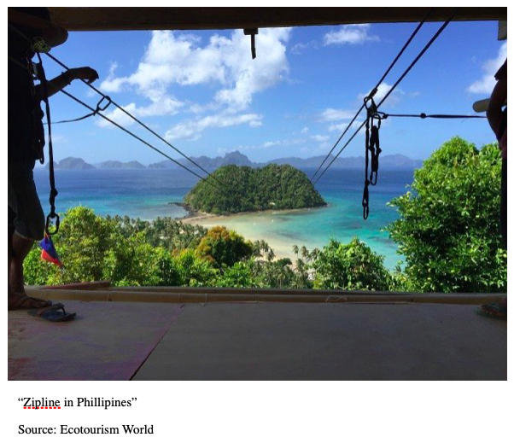
Today, ecotourism is a swiftly growing industry, as more and more travelers become conscientious of the negative environmental impact of traveling to environmentally fragile areas. While the COVID-19 pandemic resulted in a widespread decline of tourism worldwide, as of 2021, the market has largely recovered and the ecotourism sector is appearing only to grow. Data from a 2021 economic study valued the global ecotourism market at almost $200 billion and predicted that it will grow annually by 15% from 2022 until 2030.

This rapid growth in ecotourism is largely motivated by increased demand from travelers. According to a 2019 study, 55% of global travelers are committed towards traveling more sustainably, with younger travelers (especially millennials and older members of Generation Z) especially interested in ecotourism. Today, there are hundreds of organizations worldwide committed to promoting ecotourism, encouraging cooperation amongst tour operators, and providing training for entrepreneurs interested in ecotourism.

Despite increased interest in ecotourism and its environmental and economic benefits, many states and regions have yet to invest in the ecotourism market. On the other hand, the rise in ecotourism globally makes it clear that ecotourism can have just as many negative effects as positive ones. More international regulation, guidance, and frameworks may be necessary to increase its positive benefits and reduce its negative ones.

Benefits of Ecotourism:

While ecotourism’s main role is to decrease the negative effects of tourism on natural environments, it also holds economic and social benefits for countries that invest in ecotourism.

Ecotourism’s stated purpose is to make tourism more environmentally beneficial and reduce the impact of increased travel on ecosystems. It is a useful tool in conservation of natural environments, as it provides economic justification for preserving the environment and, ideally, creates revenue that can then be put back into the natural environment. For example, in Madagascar, 50% of national park entrance fees is set aside for sustainable development projects. Local communities and governments now view the preservation of natural environments as a source of economic revenue, meaning that they are less likely to be destroyed in order to create space for industry or agriculture.

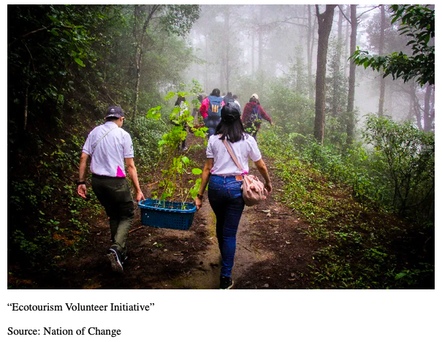
Ecotourism enterprises often include educational elements, teaching travelers about native plant and animal species, biodiversity, and environmental concerns currently facing a region. These ecotourism ventures increase travelers’ environmental consciousness and knowledge, in addition to reducing their negative impact. In addition, ecotourism tends to create more opportunities for environmental education within the local population, too.

Finally, some ecotourism ventures are also categorized as “voluntourism,” a type of travel in which visitors volunteer to give back to local environments and communities. While voluntourism can include a variety of activities from volunteering in orphanages to building houses, environmentally sustainable voluntourism might include activities like cleaning up ecosystems, restoring deforested regions, or assisting in the birth of endangered animals. While controversial, voluntourism focused on the conservation of nature can lead to positive impacts.

Aside from its clear environmental benefits, ecotourism also tends to deliver economic and social benefits to local communities. It has proven to be a source of sustainable long-term income for communities. In comparison to industries like logging and agriculture that result in destruction of local habitats, it also generates more revenue over time.

Ecotourism is proven to create job opportunities for local residents, often more so than other forms of tourism. While resort tourism and more “standard” forms of tourism are often operated by large corporations and foreign companies, ecotourism is often led by local small businesses instead.

Criticism of Ecotourism:

Despite the proven benefits of ecotourism, the sector often receives criticism due to its negative impacts on local communities, mismanagement, and, ironically enough, potential negative impact on the environment it is devoted to protecting. It is important to note that many of the more negative impacts of ecotourism disproportionately affect communities in low and middle-income countries, as well as regions where racial and socioeconomic dynamics lead to inequality already.

Impact on Local Communities and Indigenous Peoples:

One of the core traits of ecotourism is ensuring that local communities benefit from and are not harmed by tourism ventures. However, the development of ecotourism still sometimes leads to disruption of everyday life and other negative effects on local communities. For instance, increased tourist activity generated by ecotourism requires more physical infrastructure, like hotels. At times, local communities are displaced by the construction of these accommodations.

In addition, when mismanaged, the creation of conservation areas for ecotourism purposes can result in the displacement of Indigenous peoples. For instance, in Tanzania, the Indigenous Malasi herdsmen have been essentially “evicted” by the Tanzanian government for the purpose of expanding nature reserves and national parks in their ancestral homeland. While the government insists that this is a “voluntary relocation,” these policies have resulted in contentious land disputes, use of police force against protesters of the displacement, and potential human rights violations.

Ecotourism is applauded for its ability to create job opportunities for local residents, but these jobs are typically low-paying and may provide little opportunities for advancement. In addition, even though ecotourism generally advantages small businesses and locally owned ventures rather than foreign corporations, the money generated from ecotourism often returns to high-income states regardless.

Just as ecotourism is meant to benefit local communities and have direct positive effects, it is also intended to promote Indigenous cultures and benefit Indigenous peoples. While ecotourism often includes cultural elements and education, this commercialization can sometimes lead to stereotyped versions of Indigenous cultures.

Impact on the Environment:

Despite its purpose of minimizing the environmental impact of tourism, ecotourism sometimes, ironically enough, damages the natural environment instead. Ecotourism increases the amount of visitors to regions in general, so, even if it has a lesser negative environmental impact than other forms of tourism, it can still cause stress upon natural environments and wildlife from over-tourism.

In regions rich in diverse wildlife, increased ecotourism activities can sometimes have a negative effect on native species by disrupting their natural behaviors or leading to loss of habitat. Similarly, the increased number of tourists generated by ecotourism means communities often need to build more hotels and other infrastructure to accommodate these visitors. When mismanaged, this development can lead to deforestation and habitat loss.

Defining Ecotourism:

The lack of a universally recognized and enforceable definition for ecotourism creates confusion, greenwashing, and thousands of tourism ventures worldwide that masquerade as ecotourism, despite environmentally and socially harmful practices. “Greenwashing” is a marketing strategy used by businesses to make people falsely believe that their products or services are environmentally friendly and is especially prevalent within the tourism industry. Tourism enterprises may advertise themselves using terms like “nature,” “green,” or “low impact,” but that does not always mean that they meet the definitions of ecotourism. Businesses and many governmental tourism organizations embrace the ambiguity of ecotourism and label any tourism venture that incorporates nature or wildlife as ecotourism.

International and ecotourism organizations have established clear criteria for what is and is not ecotourism, but this criteria is not widely understood by travelers and results in mislabeling and misconceptions. For example, while hunting and fishing tours may be considered “nature tourism,” or tours that take place outdoors, they are not considered ecotourism due to their impact on local wildlife. Visitors often assume that any tourism venture located in nature is environmentally friendly and an example of ecotourism, even when this is not the case.

Potential Solutions and Case Studies

Case Study One: Costa Rica

Costa Rica is widely considered a “gold standard” for the development and expansion of ecotourism ventures. The small Latin American state’s success in the ecotourism industry demonstrates that, if governments and organizations are willing to invest in information-sharing and encourage businesses to develop ecotourism ventures, this can create positive economic benefits in the long-term. Today, Costa Rica is known internationally for its large ecotourism industry.

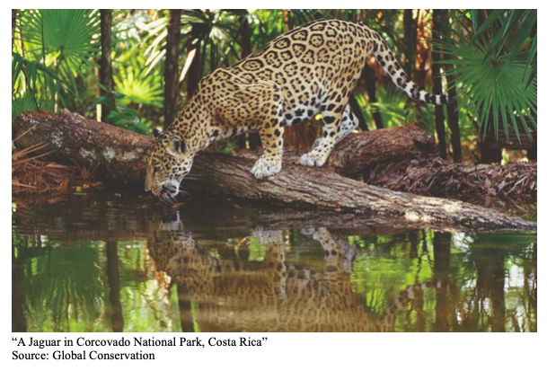
Much of the success of ecotourism in Costa Rica is due to the development of its Certification for Sustainable Tourism Program. Given that many issues with ecotourism arise due to the lack of a definition for ecotourism, this ecotourism index allows Costa Rica to clearly define and publicize ecotourism within its borders. Tourism businesses can fill out an application by answering a series of simple questions about their environmental practices. These applications are then evaluated, with businesses receiving a rating based on their sustainable practices and ecotourism incorporation.

Preservation and environmentally friendly practices are crucial in Costa Rica, with its rich ecosystems and large biodiversity. Over 25% of the country is preserved as national parks or wildlife reserves. Many of these preservation areas take even more measures to minimize the environmental impact of tourism. For example, Costa Rica’s Corcovado National Park requires a guide to visit it and sets a limit on the number of daily visitors. By enacting policies like this, Costa Rica has made sure that its most vulnerable natural areas are even more protected.

Ecotourism’s success in Costa Rica reaches beyond the protection of the natural environment and has also helped to alleviate poverty in the country. For example, communities near conservation areas in Costa Rica experienced 16% lower rates of poverty than other areas, showing that the sustainable employment opportunities created by ecotourism have paid off.

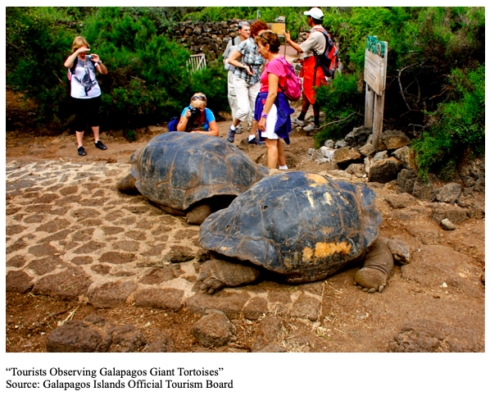
Case Study 2: Ecuador

Another popular ecotourism destination and an excellent example of sustainable tourism practices is Ecuador’s Galapagos Islands. Known for their natural beauty and biodiversity, the island archipelago is a popular destination for nature-lovers worldwide, but, if left unregulated, could face environmental degradation due to overtourism.

Fortunately, Ecuador’s tourism authority has enacted a number of policies to promote sustainable practices and prioritize ecotourism in the Galapagos. Every natural environment has a “carrying capacity,” or a limit on the amount of people that it can sustain. In the Galapagos, the national park has taken carrying capacity into account when planning boat routes for visitors and limiting the daily amount of visitors. Only a certain number of visitors are allowed at some natural sites at a time. In addition, visitors have to pay a park entrance fee that goes directly to conservation.

In addition, visitors to the Galapagos Islands must visit the islands with a guide rather than independently. This way, the national park can ensure that visitors act responsibly and do not endanger wildlife or the natural ecosystem.

However, despite the environmentally responsible policies and frameworks of the Galapagos Islands, the impact of ecotourism is not solely positive. Though the national park sets limits on daily visitor numbers, many worry that the limits are too high and result in over-tourism, with ten times as many visitors traveling to the Galapagos archipelago today compared to when the islands first saw tourists in the 1980s. In addition, contamination from poorly maintained ships and wastewater has been found in the natural environment. As such, despite the positive impacts of ecotourism in the Galapagos, more regulation is necessary in order to prevent unsustainable practices and over-tourism.

Potential Solutions:

This list below is a very short selection of some of the general solutions suggested by experts. Consider how this might work with your country policy, and which of these solutions could be implemented domestically versus on an international level:

- Involve local community leaders and Indigenous voices in decision-making processes.
- Increase economic benefits for local communities by limiting foreign investment and empowering small businesses. 0
- Ensure sustainability when considering construction of accommodations, sourcing materials for ecotourism, and incorporating renewable energy.
- Increase collaboration and communication amongst governmental agencies, ecotourism organizations, and business owners.

Questions to Consider

- Given the high levels of knowledge and generally higher costs required to develop ecotourism ventures, how can the UNWTO best support low and middle income countries in the development of ecotourism ventures?
- How can states and international organizations best incentivize businesses in the tourism industry to adopt sustainable practices and develop ecotourism ventures? How should approaches differ for locally-owned businesses versus large corporations?
- The impacts of ecotourism differ greatly around the world (for example, ecotourism will have a very different effect in a high-income country versus a small-island developing state). Should this committee approach the issue of ecotourism through universal, global solutions or regional strategies?
- How can this committee use the example of states who have successfully developed sustainable ecotourism industries to guide international policy? How should this policy be adapted if it is to be applied worldwide?
- The UNWTO already has a working definition for ecotourism, but there is still confusion over its definition and how this works in practice. How should this committee approach confusion over what is and isn’t ecotourism?
- Whose interests should this committee prioritize when creating policy (local governments, business-owners, environmental activists, Indigenous peoples, large corporations, etc)?
- Increasing a state’s ecotourism industry means expansion of the tourism industry in general, even if ecotourism practices are more sustainable. How should public and private organizations approach ecotourism in regions that face overtourism?

Bibliography

Arooba, Ahmed et al. “How Ecotourism Can Harm Indigenous Communities.” State of the Planet, 1 June 2020, https://news.climate.columbia.edu/2020/06/02/ecotourism-indigenous-communities/.
Booking global. “Booking.com Reveals Key Findings from Its 2019 Sustainable Travel Report.” Booking Global, 28 May 2019, https://globalnews.booking.com/bookingcom-reveals-key-findings-from-its-2019-sustainable-travel-report/.
Briney, Amanda. “How to Practice Ecotourism in Endangered Locations.” ThoughtCo, ThoughtCo, 23 Jan. 2020, https://www.thoughtco.com/what-is-ecotourism-1435185.
“The Business of Voluntourism: Do Western Do-Gooders Actually Do Harm?” The Guardian, Guardian News and Media, 13 Sept. 2018, https://www.theguardian.com/news/2018/sep/13/the-business-of-voluntourism-do-western-do-gooders-actually-do-harm.
“Certification for Sustainable Tourism Program.” Go Visit Costa Rica, https://www.govisitcostarica.com/travelInfo/government-programs/cst-program.asp.
“Costa Rica National Parks and Reserves Encompass More than 25% of the Country.” Go Visit Costa Rica, https://www.govisitcostarica.com/travelInfo/nationalParks.asp#:~:text=25%25%20of%20Costa%20Rica%20is,environs%20from%20deforestation%20and%20logging.
Earth Changers. “Earth Changers Blog: Greenwashing in Sustainable Tourism & Responsible Travel.” Earth Changers, Earth Changers, 16 June 2020, https://www.earth-changers.com/blog/2018/9/25/greenwashing-in-sustainable-tourism-amp-responsible-travel.
“Eco-Tourism: Encouraging Conservation or Adding to Exploitation?” PRB, https://www.prb.org/resources/eco-tourism-encouraging-conservation-or-adding-to-exploitation/.
“Ecotourism and Protected Areas.” UNWTO, https://www.unwto.org/sustainable-development/ecotourism-and-protected-areas.
“Ecotourism Market Size, Share & Growth: Global Report, 2030.” Ecotourism Market Size, Share & Growth | Global Report, 2030, https://www.grandviewresearch.com/industry-analysis/ecotourism-market-report#:~:text=The%20global%20ecotourism%20market%20was,USD%20208.63%20billion%20in%202022.
Ecotourism World. “Everything You Need to Know about Benefits of Ecotourism.” Ecotourism World, 18 Oct. 2022, https://ecotourism-world.com/everything-you-need-to-know-about-benefits-of-ecotourism/.
Gallagher, Katherine. “What Is Ecotourism? Definition, Examples, and Pros and Cons.” Treehugger, Treehugger, 13 Dec. 2022, https://www.treehugger.com/what-is-ecotourism-definition-examples-5181259.
Honey, Martha. “The Ecotourism Revolution.” SlideShare, https://www.slideshare.net/ragwald/the-ecotourism-revolution.
“The Impacts of Tourism.” Discovering Galapagos, 1 Jan. 2017, https://www.discoveringgalapagos.org.uk/discover/sustainable-development/sustainable-tourism/impacts-of-tourism/#:~:text=Sadly%2C%20not%20all%20tourists%20or,even%20into%20drinking%20water%20supplies.
Jeannin, Marine. “In Tanzania, the Maasai Are Evicted from Their Land in the Name of Wildlife Protection and Tourism.” Le Monde.fr, Le Monde, 23 June 2022, https://www.lemonde.fr/en/international/article/2022/06/23/in-tanzania-the-maasai-are-evicted-from-their-land-in-the-name-of-wildlife-protection-and-tourism_5987719_4.html.
“Managing Ecotourism in Galapagos.” Discovering Galapagos, 1 Jan. 2017, https://www.discoveringgalapagos.org.uk/discover/sustainable-development/sustainable-tourism/managing-ecotourism-in-galapagos/.
Peters, Joe. “Sharing National Park Entrance Fees,” Society and Natural Resources 11, no. 5 (1998).

“The Three Main Benefits of Ecotourism and How to Promote It.” TravelPulse, https://www.travelpulse.com/news/features/the-three-main-benefits-of-ecotourism-and-how-to-promote-it.html.
“World Tourism Organization (UNWTO).” UNWTO | UNIDO Knowledge Hub, https://hub.unido.org/multilateral-agencies/unwto.
Zhao, Yufeng, and Lei Jiao. “Resources Development and Tourism Environmental Carrying Capacity of Ecotourism Industry in Pingdingshan City, China - Ecological Processes.” SpringerOpen, Springer Berlin Heidelberg, 14 Mar. 2019, https://ecologicalprocesses.springeropen.com/articles/10.1186/s13717-019-0161-0#:~:text=The%20ecotourism%20environmental%20carrying%20capacity,environment%20and%20reduce%20the%20impact.

“World Tourism Organization” (UNWTO).
“World Tourism Organization (UNWTO)” (UNIDO Knowledge Hub).
“Ecotourism and Protected Areas” (UNWTO).
“Everything You Need to Know about Benefits of Ecotourism” (Ecotourism World, 2022).
Amanda Briney. “How to Practice Ecotourism in Endangered Locations” (ThoughtCo, 2020).
“Ecotourism and Protected Areas” (UNWTO).
Martha Honey. “The Ecotourism Revolution” (SlideShare).
Katherine Gallagher. “What Is Ecotourism? Definition, Examples, and Pros and Cons” (Treehugger, 2022).
“Ecotourism Market Size, Share & Growth: Global Report, 2030” (Grand View Research, 2022).
“Greenwashing in Sustainable Tourism & Responsible Travel” (Earth Changers, 2020).
“Booking.com Reveals Key Findings from Its 2019 Sustainable Travel Report” (Booking Global, 2019).
“The Three Main Benefits of Ecotourism and How to Promote It.” (Travel Pulse).
Joe Peters. “Sharing National Park Entrance Fees” (Society and Natural Resource, 1998).
“Eco-Tourism: Encouraging Conservation or Adding to Exploitation?” (PRB).
“Eco-Tourism: Encouraging Conservation or Adding to Exploitation?” (PRB).
Clem Tisdell. “Ecotourism, Economics, and the Environment: Observations from China” (Journal of Travel Research, 1996).
Ahmed Arooba et al. “How Ecotourism Can Harm Indigenous Communities.” (New York City: Columbia University, 2020).
“The Business of Voluntourism: Do Western Do-Gooders Actually Do Harm?” (The Guardian, 2018).
Marine Jeannin. “In Tanzania, the Maasai Are Evicted from Their Land in the Name of Wildlife Protection and Tourism.” (Le Monde, 2022).
“Certification for Sustainable Tourism Program” (Go Visit Costa Rica).
“Costa Rica National Parks and Reserves Encompass More than 25% of the Country” (Go Visit Costa Rica).
Yufeng Zhao and Jiao Lei. “Resources Development and Tourism Environmental Carrying Capacity of Ecotourism Industry in Pingdingshan City, China - Ecological Processes” (Springer Berlin Heidelberg, 2019).
“Managing Ecotourism in Galapagos” (Discovering Galapagos, 2017).
“The Impacts of Tourism” (Discovering Galapagos, 2017).

