UN Sustainable Deveopment Goal Five
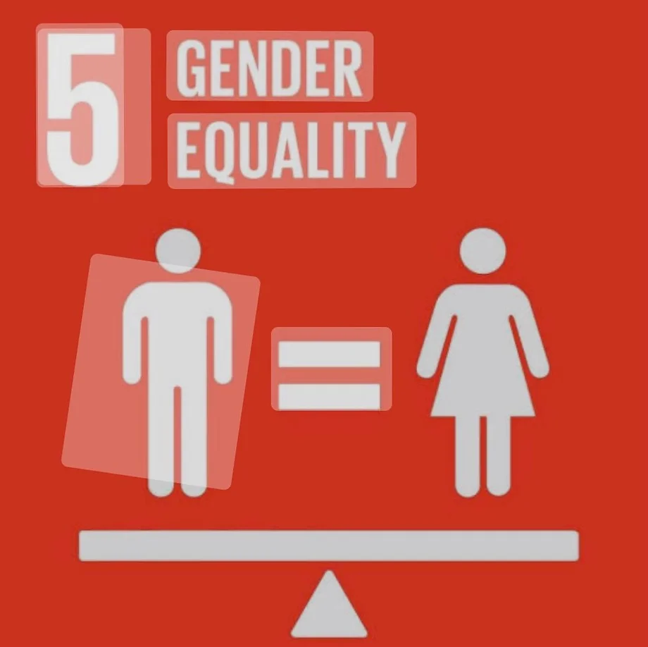

Table of Contents:

Letter from the Cahir
Role of the Committee
Historical Background
Current situation and Topic
- Women in the workforce
- Reproductive Health
Committee Composition
Questions to Consider
References

Letter from the Chair:
Hello Delegates!
Happy New Year, and best wishes for a healthy and happy 2023! I wanted to take the time to introduce myself ahead of the start of the committee. My name is Anne Culhane-Williams, and I am from Framingham, Massachusetts, but I have come to love Clark and Worcester. I am a junior at Clark University, double majoring in Mathematics and Political Science with an American Politics track and a minor in History. I am also on Clark’s rowing team and President of Clark’s chapter of the Association of Women in Mathematics! I eventually want to go to law school and work for the government or into mathematical modeling—I haven’t quite figured that out yet! This past fall, I studied abroad in Sydney, Australia, but I am eager to get back into Model UN! When I am not doing math problems or attempting to solve the world’s political issues, I can be found drinking excessive amounts of coffee and obsessing over the British Royal Family – and I fully expect everyone to be caught up on the 5th season of the Crown (but it wasn’t that good)! J
This is my second time chairing at ClarkMUN; in 2022, I chaired a Brexit committee and vice-chaired in 2021 a UNEP focusing on trees. I am incredibly passionate about math education especially involving women and girls learning and loving math from a young age. The lack of education in various parts of the world for women and girls is shocking, but I want to change it and hope to see our committee find solutions to do so. I am trying to keep this background guide on the shorter side as I want to see the research and solutions you, as delegates, come up with.
I look forward to seeing various solutions, insightful debates, and arguments you can come up with!
If you have questions on committee structures, goals, the topic, career questions, or college questions, feel free to reach out at aculhanewilliams@clarku.edu!

Kind regards,
Anne

Role of the Committee
The role of this committee, while different from conventional UN committees, is to find strategic ways to achieve gender equality and empower all women and girls. While this issue may seem obvious as to why it should be addressed, to some, it is not. It is crucial to understand precisely why so many people advocate for women and girls. Notably, they make up roughly half of the world’s population and thus are stakeholders in the success of the world as a whole.
I would like to see the committee address two more specific initiatives: women in the workforce and reproductive health. What does it mean to have women in the workforce? How many women? What about women who want to stay home/ be stay-at-home parents? There are many questions to consider while being sensitive to different cultures. The committee will attempt to discuss these and find fair and representative resolutions to these complex and challenging issues.
Historical Background
This committee is relatively new to the UN, as the strategic developmental goals were established in 2015. For years, different committee agendas and resolutions have been set toward discussing women’s issues. There have been various dialogues and summits to address multiple goals at a time, but rarely has sole attention been dedicated to this goal. Still, this strategic goal was the first time the sole focus was on gender equality issues.
Notably, there are various initiatives different bodies have taken throughout history to discuss women’s issues, including International Women’s Day, Women’s History Month, Beijing Declaration and Platform for Action, the Convention on the Elimination of All Forms of Discrimination Against Women, and the Commission on the Status of Women. While these initiatives have taken necessary steps towards being more inclusive of women and girls, much more is still to be done.
Current situation and Topic
This committee will focus on two subtopics: women in the workforce and reproductive health and equality. Women accounted for 39% of total employment in 2019 and were found to quit their jobs to care for their families more during the COVID-19 pandemic than their male counterparts. Moreover, the UN estimates that it will take another 40 years for “women and men to be represented equally in national political leadership at the current pace” (SDG Website).
Women are more likely to find themselves in unhealthy relationships, become mothers at a young age, and are at a higher risk for sexually transmitted diseases. Furthermore, only 57% of women ages 15-49 make their own informed decisions on sex and reproductive health care (SDG website). This is incredibly dangerous for women worldwide as people are not in control or taught about their bodies.
The UN has outlined several targets and indicators to measure these bold goals' success. Notably, Target 5.4: “Recognize and value unpaid care and domestic work through the provision of public services, infrastructure, and social protection policies and the promotion of shared responsibility within the household and the family as nationally appropriate” (SDG). They explain that this can be measured by the proportion and time spent on unpaid domestic and care work by sex, age, and location.
Moreover, Target 5.6 explains, “ensure universal access to sexual and reproductive health and reproductive rights as agreed in accordance with the Programme of Action of the International Conference on Population and Development and the Beijing Platform for Action and the outcome documents of their review conferences” (SDG). These goals can be measured through a proportion of women who make their own informed decisions regarding sexual relations, contraceptives and reproductive healthcare, and the number of “countries with laws and regulations that guarantee full and equal access to women and men aged 15 years and older to sexual and reproductive health care information and education” (SDG). The work that needs to go into seeing this target succeed is up to the governing bodies to set forth additional planning.

Committee Composition
- Afghanistan
- Australia
- Bahamas
- Bangladesh
- Bosnia and Herzegovina
- Brazil
- Cambodia
- Congo (Republic of the)
- Denmark
- Ecuador
- Egypt
- El Salvador
- Ethiopia
- Finland
- France
- Germany
- Greece
- Guatemala
- Haiti
- India
- Israel
- Mexico
- Pakistan
- Peru
- Portugal
- Qatar
- Russian Federation
- Saudi Arabia
- Serbia
- Sweden
- Turkey
- UK
- Ukraine
- USA
- Zambia

Questions to Consider:
- How can we develop strategic frameworks to increase gender equality in smaller countries without compromising religious and cultural norms and traditions and impeding cultural sensitivity?
- What goals does the committee want to achieve when discussing women in the workforce?
- What does adequate and equal reproductive healthcare look like? And how does one achieve that?

References
“About UN Women.” UN Women – Headquarters, https://www.unwomen.org/en/about-us/about-un-women.
“Goal 5 | Department of Economic and Social Affairs.” United Nations, United Nations, https://sdgs.un.org/goals/goal5.

