UN Security Council: Apocalypse

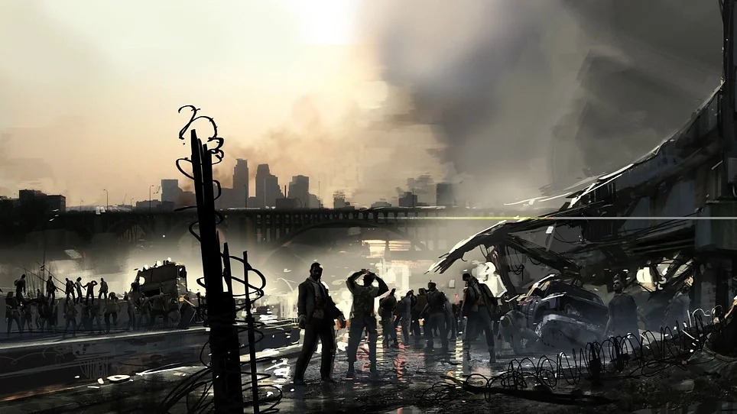

Table Of Contents:

Letter from the Director 2
Introduction and Role of the Committe 3
Historical Background 4
Character List 5
Questions to Consider 9

Letter From the Director:

Delegates,

Welcome to the committee on UN Security Council: Apocalypse. My name is Larissa Lenkey and I will be one of your co-chairs. A little about me is that I am a freshman at Clark this year and this is the first time ever that I have done Model UN. I am an intending on majoring in political science with a concentration in international relations. Besides being in ClarkMUN I also am part of the hall council for my dorm.
I am big on theorizing about potential catastrophic occurrences that could partake and why. I really enjoy apocalyptic-type genres such as tv shows or movies and games. The thought of a committee on a zombie apocalypse is intriguing with the many different twists and turns that could result based on your actions.
I hope you all are as excited for this committee like me and I can’t wait to meet you all and see the different paths that are going to occur. Delegates, you, will fill as the roles of current or past UN Security Council members. All these characters have something different about themselves than the rest. I look forward to what you will use as your advantage from your character. Best of luck!

If you have any questions about anything feel free to send me an email.
llenkey@clarku.edu

Sincerely,
Larissa Lenkey

Introduction and Role of the Committee:

It is 2089, and it is a few months into a zombie apocalypse. The world is in a panic, the leaders don’t know how to resolve the situation, and the ratio of zombies to humans is diminishing by the day. Hunger, infection, and panic are all surging problems for different states alike but are also what is keeping them together. From the beginning of the world to now you haven’t had to worry about the end like it is today, your country's future is on the line. No country by itself is willing to try and find what lab created it, let alone work together to deploy action across different countries for the benefit of humanity. The zombie population is slowly growing as the day goes on, the threat to mankind as we know is at stake, and all hope is diminishing until…..
Welcome to U.N. Security Council: Apocalypse. A committee dedicated to solving world issues as countries come together by leaders to discuss and act on pressing issues; to maintain peace and security. You have all been tasked with finding the main source of where this zombie apocalypse first occurred and how to bring humanity back together. But be cautious the country whose lab invented what caused this is amongst yourselves. They are in the high ranks among international relations, watch out you don’t want to have your state overshadowed. Luckily, for you all, you are past council leaders who have returned, and no not as zombies. Good luck councilmen!

Historical Background:

The UN Security Council has dealt with many catastrophic instances in the past. The council members have dealt with infectious diseases, like ebola, as well as hunger problems. The council men all collectively joined together to solve these issues at hand. The Security Council for the problems they are trying to solve talk and converse about the problems around the world as they talk about other organizations and there efforts as well like the World Health Organizations (WTO). In doing so they worked to set presidents for the countries being majorily effected by ebola. In doing this it has lead to conversations about effective measures to slow the spread ebola. When using information from other organizations the council members discuss about how they will put pressures and reiterate these problems to the infected countries as well as how the other countries will use their efforts and resources as being part of these countries to fix these problems. In previous years the security council has used the the problems of hunger across countries to enact plans to decrease food insecurity. They started this plan from debriefing about each countries take on the issue and where they stand in terms of resolution.
But in order for these council members to declare these as an issue at hand to try and resolve issues like infectious disease or hunger that are present they had to be declared issues. When ebola was declared as a public health emergency by the WTO. The Security Council then referred to ebola as a threat to international peace and securtiy when in doing so it lead to them putting these proposed solutions to the countries that are majorily effected. As well when the council men discussed about the hunger problems occurring in countries and to network to try and resolve the problem they declared it as conflict induced food insecurty since the hunger problem can be a result from war and conflict between different states and from within a state itself.

Character List:

Delegates here is a list of the current and past Security Council members. We have provided you with a brief summary of their work. We deeply encourage all of you to take time and research more about your character that includes more about their life and work etc.

Zhang Jun (China): A permanent member of the Security Council, since 2019. Before that Jun was Ambassador Extraordinary and Plenipotentiary of the People's Republic of China for the Netherlands, from 2007 to 2012.

Nicolas De Riviere (France): A permanent member since 2019. From 1994 to 2001 De Riviere was the first secretary of the Embassy of France in the United States and the Netherlands. Previously, he worked for the Ministry of Foreign Affairs from 2002 to 2005. From 2005 to 2010 he assumed the roles of the political counselor as well as deputy permanent representative in the UN. As well as achieving the role of Assistant Secretary for the United Nations, international organizations, human rights and Francophonie from 2011 to 2014. Then he became the director of political affairs and security from 2014 to 2019.

Vassily Nebenzia (Russia): A permanent member since 2017 after being appointed by President Putin. After the invasion of Ukraine in 2022 while being president of the council there were calls for his resignation but Nebenzia didn’t.

Barbara Woodward (United Kingdom): The permanent representative in 2020 by the foreign secretary. Before assuming the role she was the British Ambassador to China; Woodward is a China expert. Woodward had also previously worked in Russia as the second and then first secretary. Some hobbies of hers include competitive swimming as well as tennis.

Linda Thomas- Greenfield (United States): Was appointed to the position by President Biden in 2021 after being confirmed by the Senate. During 2013-2017 Thomas worked as the assistant secretary of state for African affairs She retired in 2017 from the State Department where she led the Africa Practice for a commercial diplomacy firm.

Ferit Hoxha (Albania): Is the permanent representative since 2021, but he also served in the role from 2009 through 2015. Hoxha started working for the Albanian government in 1991 when he assumed a role in the Albanian Ministry of Foreign Affairs. He worked as Head of Mission for the European Union as a representative for Albania from 1991 to 2001. Hoxha worked as an ambassador to France and Portugal. As well as working as the Governor of the International Atomic Energy Agency (IAEA) Board of Governors, for Albania from 2007 to 2009.

Ronaldo Costa Filho (Brazil): Brazil’s permanent UN representative since 2020. He previously held this position from 1991 to 1995. From 2008 to 2011 Costa represented Brazil in the European Union. From 2001 to 2003 he upheld the position of Brazil's Permanent Mission to the UN in Geneva. Costa also worked in embassies in Ecuador and Quito from 1995 to 1998. Costa held positions from Director of the Extra-Regional Trade Negotiations Department and Head of the Services to Investments and Financial Affairs Division.

Michel Xavier Biang (Gabon): Permanent UN representative since 2017. Before taking this role in 2015 he held the position of ambassador to the Democratic Republic of Congo. Biang held a position as a secretary to the National Climate Council in charge of international climate-change negotiations from 2014 to 2015. Biang also worked from 2012 to 2014 as a Director of Legal Affairs at the National Civil Aviation Agency. Additionally Biang worked from 2010 to 2012 at the Ministry of Foreign Affairs as a diplomatic and legal advisor. Before assuming these roles Biang also worked from 2002 to 2012 as a territorial disputer between Gabon and Equatorial Guinea part of the national commission.

Harold Adlai Agyeman (Ghana): Was appointed permanent member in 2021. Agyeman served from 2009 to 2011 as securing senior roles in Ghana’s High Commission to India. From 2012 to 2014 he served as the Director of the Staff Training and Development Unit in the Administration Bureau in the Ministry of Foreign Affairs. As well as from 2014 to 2018 he acquired a position in Ghana’s Embassy in Benin as Minister Plenipotentiary and Deputy Head of Mission. From 2018 to 2021 he assumed the roles of Director of the Ministry’s Africa and Regional Integration as well as Director of the Administration Bureau in the Ministry of Affairs.

Lana Zaki Nusseibeh (United Arab Emirates): A permanent representative since being appointed in 2013. From 2000 to 2001 she was a consultant for the United Nations Education, Scientific and Cultural Organization. In comparison, working as an analyst from 2004 to 2006 for Security and Terrorism Program. Before her work with UAE’s Ministry of Foreign Affairs, she was the head of the International Renewable Energy Agency. She is the Co-Chair of the Friends for the Future of the UN. As well as partaking as a member of the Board of Trustees of the Emirates Diplomatic Agency.

Hernan Perez Loose (Ecuador): A permanent member since 2022. He is a founding partner of the Coronel & Pérez Law Firm in 1991. From 2002 to 2022 he worked as the Arbitrator at the Arbitration and Mediation Center of the Guayaquil Chamber of Commerce. Additionally Loose worked in the Ministry of Foreign Affairs in the Commission Number 1 for Peace Negotiation with Peru, in 1998. From 1982 to 1995 he served as a legal advisor to the National Council for Modernization of the State and State Attorney General. In 1979 he worked in the Ministry of Public Education as the secretary.

Ishikane Kimihiro (Japan): Was appointed to the permanent position in 2019. He joined the Ministry of Foreign Affairs in 1981. From 1996 to 1998 he held a role working as the first secretary in the Embassy of Japan in France. As well as the director of the First Africa Division from 1991 to 2001. Kimihiro also worked as minister of the Embassy of Japan in the United States from 2005 to 2007. Then from 2007 to 2008, he worked as an executive assistant to the Prime Minister. From 2014 to 2015 Kimihiro worked as Director‑General of the International Cooperation Bureau. Then assumed the position of Director‑General of the Asian and Oceanian Affairs Bureau from 2015 to 2016, before moving on to the ambassador of Japan in Canada.

Vanessa Frazier (Malta): Assumed the role of permanent representative in 2020. She was a student diplomat in 1992. In 1994 she has appointed the role of first secretary when working as desk officer of the United States and the Americas, and the Mediterranean Department. She was an ambassador to Luxembourg Belgium and NATO. Then in 2013, Frazier was Malta’s ambassador to Italy.

Pedro Comissario Afonso (Mozambique): Became the permanent representative in 2020. From 2002 to 2016 he was a member of the International Law Commission as well as becoming president of the commission in the later years of his membership. Afonso was the ambassador to the Nordic countries based in Stockholm from 2006 to 2012. As well as assuming the roles of the UN World Trade Organization, UN Industrial Development Organization, and International Atomic Energy Agency permanent members additionally being ambassadors to the Swiss Confederation between 2012 and 2018. Before gaining his current role Afonso was Director of the Central Bureau for the Prevention and Combat against Drugs from 2019 and 2020.

Pascale Christine Baeriswyl (Switzerland): Assumed being the permanent representative in 2020. She was a judge after being elected to the Civil Court of Basel province from 1998 to 2001. While in 2000 Baeriswyl became the Directorate of International Law and in the Embassy in Hanoi. Then moving on to the position of Deputy Head of the Human Rights Policy Section at the Federal Department of Foreign Affairs’ Asia desk. From 2005 to 2008 she upheld the position of foreign and security policy for the Swiss in the European Union. Baeriswyl was the head of the political team for the Swiss mission to the UN from 2008 to 2013. Then in 2013, she became the vice director of the Federal Department of Foreign Affairs Directorate of International Law. While in 2016 she was appointed as Switzerland’s State Secretary. Before becoming part of the security council Baeriswyl was part of the World Economic Forum’s Future Council on Europe from 2018 to 2020.

Christoph Heusgen (Germany): He served as the German ambassador to the UN from 2017 to 2021. From 2005 to 2017 he was Under-Secretary for Foreign and Security Policy in the German Chancellery. He was part of the UN Security Council from 2018 to 2020. Since 2022 Heusgen has been chairman of the Munich Security Conference. From 1999 to 2005 he was the Director of the Policy Unit of the General Secretariat of the Council of the European Union.

Phạm Bình Minh (Vietnam): He was been the Minister of Foreign Affairs from 2011 to 2021. Minh has also been the Deputy Prime Minister of Vietnam from 2013 to 2023. He assumed the role of Attache at the United Kingdom Embassy for Vietnam from 1982 to 1985. Then from 1991 to 1999, he was the Deputy Director General of the Department for International Organizations. As well Minh worked from 1999 to 2003 as the permanent representative of Vietnam at the UN. He is a current member of the 11th Central Committee of the Communist Party of Vietnam. From 2007 to 2011 he has appointed the position Vice Minister of Foreign Affairs of Vietnam.

Dian Triansyah Djani (Indonesia): He was is the permanent representative of the UN since 2016 as well as President of the Security Council in 2019. From 2009 to 2012 he was a permanent representative of Indonesia to the UN, and World Trade Organization. From 2009 to 2010 he has appointed the position of vice president of the UN Human Rights Council. Djani was the Director General of America and Europe from 2012 to 2016. As well as from 2002 to 2005 he was the director of Multilateral Trade and Industry at the Directorate General of Multilateral Economy, Finance and Development and Asia Pacific and Africa Intra-Region Cooperation at the Directorate General in the Ministry of Foreign Affairs.

Questions to Consider:

- What power do certain countries have that will influence the participation of the other countries represented?
- How will the UN Securty Council band together to fully enact a resolution to try and stop or slow the apocalypse at hand?
- Will the country whose lab started the apocalypse be the country whose raises their voice the most or will they not own up to their catastrophic mistake leading to the downfall of mankind?
- To what extent will the countries work for the greater good and not just for their own countries individually?
- Will there be a solution that involves every countries input?
- What will it take for the council members to created an agreement?

