The Tenth Communist Party Congress of Yugoslavia, 1974
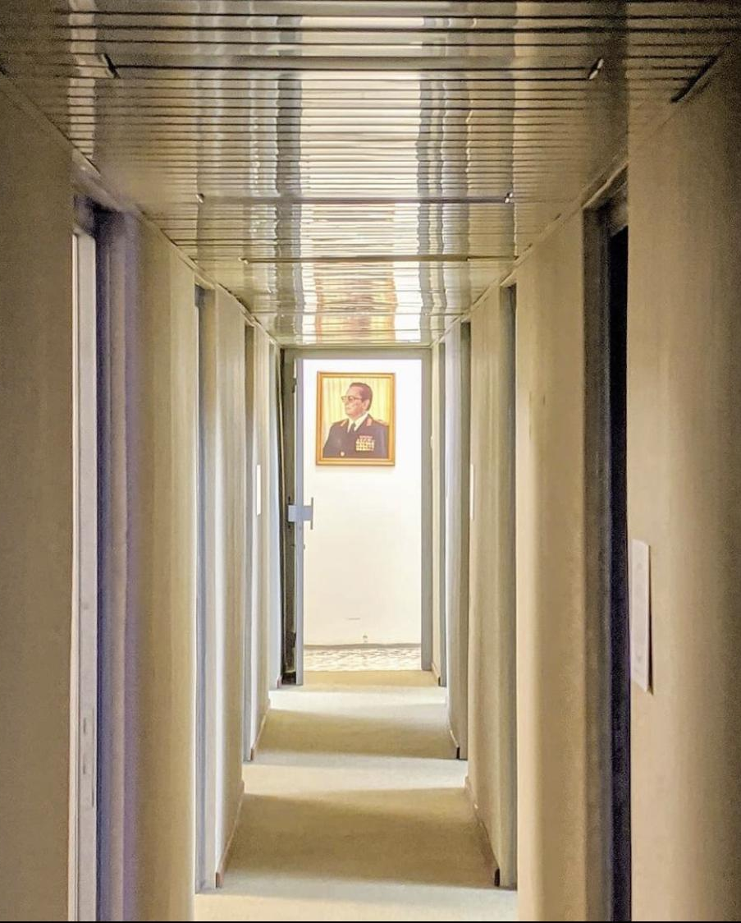
Table of Contents
Introduction and Role of Committee 2
Once, there was a country. 2
Committee Expectations 5
Historical Background 7
From Kingdom to Communist State, 1918-1946 7
Constitutional Development, 1946-1974 8
Topic: The 1974 Constitution 10
Self Management 10
Federal Structure 11
Brotherhood and Unity 14
Role of the Communist Party 16
List of Delegations 18
League of Communists of Yugoslavia 18
Yugoslav People’s Army 19
Socialist Republic of Serbia 20
Socialist Autonomous Province of Vojvodina 21
Socialist Autonomous Province of Kosovo 22
Socialist Republic of Slovenia 23
Socialist Republic of Croatia 24
Socialist Republic of Bosnia and Herzegovina 25
Socialist Republic of Montenegro 26
Socialist Republic of Macedonia 27
Questions to Consider 29
Questions: Self Management 29
Questions: Federal Structure 29
Questions: Brotherhood and Unity 29
Questions: Role of the Communist Party 30
Suggestions for Further Research 31
References 32

Introduction and Role of Committee

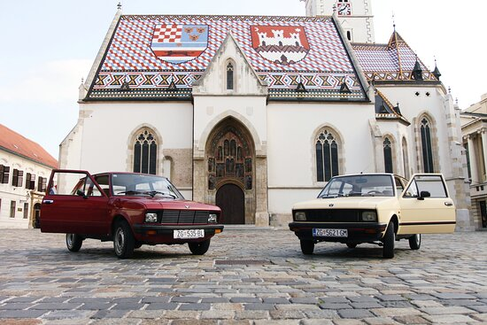

Once, there was a country.
With its admission to the Schengen area this past January, it has become easier than ever to take a Sunday stroll into Croatia, the small seaside country in Europe. Proceeding on foot through Zagreb, one can find a number of historic attractions in the capital city’s old town, such as the Lotrščak tower or the Stone Gates. Saint Mark’s Church, another iconic artifact, is intricately adorned with the recognizable red-and-white checkered insignia presently waving outside of Croatia’s national parliament building. This monument, which has stood since at least the 13th century, speaks to the cultural and historic character of the thirty-year-young nation. Still, visiting on foot can be tiresome, so if you wish to visit the parish with less strain, you can opt to tour the city by a different method: renting a vintage Yugo Car.
Since 2018, Antonija Buntak has been providing guided tours of Zagreb from her colorful fleet of Yugos. Originally minted in 1978, the blocky, manual vehicle was common in Croatia throughout the 1980s, when the country was still a Socialist Republic. The vintage appeal of the car has made it perfect for tours of the historic cityscape, where one can find decades old, brutalist high-rises alongside hollow factories and brazen monuments — remnants from a more contentious era of Croatian history, and evidence of a country which has disappeared off the map. Boundless and bare, these fixtures stand as the last pieces of Yugoslavia, a once great nation that no longer exists. And what better way to remember Yugoslavia than as a passenger of its signature car?
Croatia is one of several modern-day countries that once belonged to the Socialist Federal Republic of Yugoslavia, a federation of Communist Republics poised on the Balkan Peninsula for nearly five decades. Though we hardly remember it now, less time has elapsed between Yugoslavia’s dissolution and the present day (just over thirty years) than the time between its founding by Josip “Tito” in 1945 and its breakup. In fact, for half a century, Yugoslavia was a household name in global affairs: they voted in the United Nations and sat on the Security Council, hosted the Eurovision Song Contest, co-founded the Non-Aligned Movement, and sent teams to the FIFA World Cup and the Olympic Games. The violent collapse of the Federation from 1991-1995 was so utterly catastrophic and unprecedented that it continues to astound scholars, only furthering the Balkans’ derisive synonymy with sudden and hostile political fragmentation.
Many explanations have been put forward for the collapse of Yugoslavia. The introduction of pluralism and free elections in the 1990s resulted in ethno-nationalist parties assuming power, each of them hoping to attain different goals respective to each of Yugoslavia’s national communities. As tensions flared over economic struggles, Croatia, Slovenia, Macedonia, and Bosnia voted to leave the SFRY, violence erupted, and Yugoslavia was relegated to the history books. Although it is false to assume that Yugoslavia was always doomed to collapse, the tensions which destroyed it did not arise overnight, either. Many scholars point to the final revision of the Yugoslav Constitution, ratified in 1974, as the distant starting point of the Federation’s failure. The 1974 charter, although it recemented President Tito’s tenure as ruler for life, completely reformed the federal structure of the country into a loose, semi-confederal model of regional “self management,” weakening the national government and the role of the ruling party. Consequently, after Tito’s death in 1980, political cohesion unraveled, checks and balances buckled, and nationalist demagogues were able to exploit the decentralized federal arrangement to their advantage. Over forty years later, all of Yugoslavia’s former Republics are independent, and the once iconic Yugo is without a home.
…but, what if things had been different? If we rewind time to the Tenth Communist Party Congress, held in Belgrade in May of 1974, long before Croatian independence, before the Yugoslav Wars, and even before the first Yugo car took to the streets, we find a country younger than Croatia is today undergoing a radical and ambitious platform of political transformation. The newest constitution has just been ratified, codifying the widespread reforms which scholars have since attributed to the Federation’s downfall. Speaking to the Congress, which comprises delegations from Yugolavia’s regions and national bodies, Tito admits that “new problems and contradictions will arise” from the new system, necessitating an eventual, more critical review. In a departure from the historical record, delegates in this committee will draft and submit this review directly to Tito as one or more GA style resolutions. Representing prominent Communist Party officials, delegates must assess and recommend revisions to Yugoslavia’s 1974 constitutional order in an effort to prevent its eventual (but, from delegates’ perspective, unforeseen) collapse. Be bold, and don’t let historical constraints dictate your ideas — after all, the fate of a nation rests in your hands. ⬩

Committee Expectations
This is a General Assembly (GA) style committee, meaning that delegates will write a series of working papers with their peers and vote on a final draft resolution. The number of accepted papers and resolutions, as well as the size of their respective presentation and Q&A panels, will be determined at the discretion of the Chair (representing Marshal Tito) at the time of the conference. Since this committee is simulating a national congress rather than a UN body, draft resolutions should be addressed from “The Tenth Communist Party Congress of Yugoslavia,”. Otherwise, the format should remain consistent with typical GA draft resolutions: a series of detailed operative clauses and subclauses elaborating delegates’ policy proposals regarding the topic. If there is any confusion about how to write a Model UN draft resolution, please consult the plethora of resources available online.
Since this is a GA committee, strict decorum should be maintained at all times and debate should remain orderly and appropriate. Delegates will be representing historical individuals within a multi-person delegation, meaning that several delegates will be speaking on behalf of the same national or federal constituency. When crafting policy, priority should be kept on the interests of one's delegation as opposed to their individual “character”; delegates have no portfolio powers, nor is there any “crisis” element to this committee. Every delegate still receives one vote and full voting power on all committee matters. Delegates should also feel at liberty to interject their own original opinions and organic reactions to the background guide into their positions (i.e., what would you propose had you really been there?) Ideally, this multi-member setup should encourage lively debate and consensus building both within one’s delegation and between different delegations. A list of delegations, their viewpoints, and their members is included at the end of this background guide.
In this committee, delegates are encouraged to be detailed, inventive, and above all else, diplomatic. Though we often remember humanity for its failures, let this conference be an opportunity to celebrate our natural propensity for discussion, compromise, cooperation, and above all else, Brotherhood and Unity. ⬩

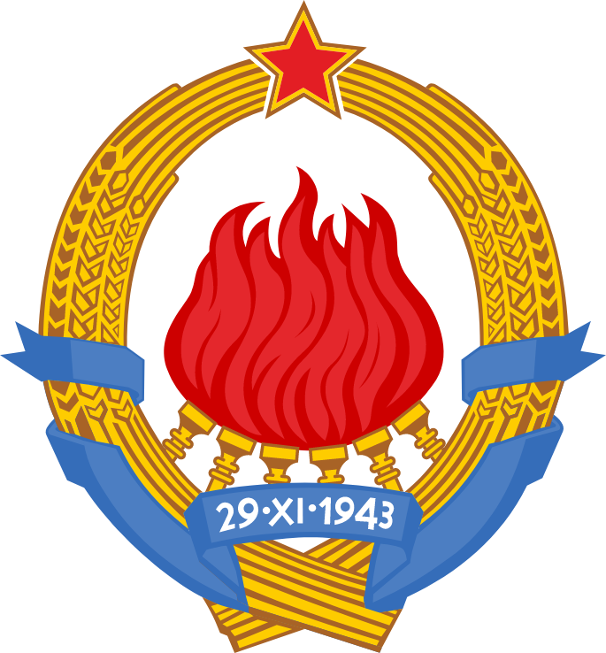

Historical Background

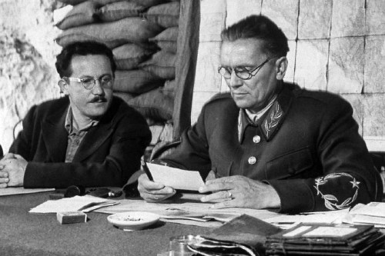

From Kingdom to Communist State, 1918-1946
The first Kingdom of Yugoslavia was brought into existence at the end of the First World War. Comprising territories taken from the dismantled Austro-Hungarian empire and the Kingdom of Serbia, the objective of the Kingdom was to unify the South Slavs (Yugoslavs), a category of different ethno-religious groups that belong to the same language family and geographic area. In Yugoslavia, these groups were Serbs, Croats, Slovenes, Montenegrins, Macedonians, and Slavic Muslims (later termed Bosniaks). Yet like many states that came into being following the First World War, Yugoslavia fell victim to Fascist incursion at the onset of the Second. In 1941, the Axis Powers invaded and occupied the Kingdom, establishing a Croatian puppet state that committed mass atrocities against the Serb, Jewish, and Romani populations of Yugoslavia. Serb nationalists and royalists organized themselves into a resistance force, the Chetniks, who waged their own campaign of bloodletting against non-Serbs on the peninsula. The World War in the Balkans was universally traumatizing and exacerbated divisions among the South Slavs that persist to this day.
Amidst the slew of bloodshed, a broad-based and multiethnic Communist uprising took shape. Led by the Croatian marshal Josip Broz “Tito,” these Partisan fighters emerged as one of the most effective irregular fighting forces of the Second World War. Tito’s Partisans ultimately triumphed over their Chetnik and Fascists adversaries, and, as the war came to a close, Marshal Tito reengineered the butchered former Kingdom into the Federal People’s Republic of Yugoslavia (later renamed the Socialist Federal Republic of Yugoslavia SFRY), a single-party Communist state commanded by none other than its chief architect, Tito himself. ⬩

Constitutional Development, 1946-1974
Having wrested themselves from foreign dominion while simultaneously toppling the crown, the Second World War was, to Yugoslavs, both a National Liberation War and a Socialist Revolution. These dual currents of nationalism and Socialism became defining and competing elements of Yugoslavia’s subsequent political discourse, where the sovereignty and equality of the country’s various Slavic groups on one hand was counterposed against the common interests of a united working class, to which expressions of nationalism appeared divisive and antagonistic, on the other. To afford some autonomy to the masses, the second Yugoslavia was federalized, dispersing power between a central state and several federal units, at least on paper. Functionally, the first Constitution in 1946 created an extremely centralized state which vested all of its power in Tito’s Communist Party. This was deemed necessary for the entrenchment of Socialism and the recovery of a country physically, economically, and socially devastated by World War. Nevertheless, the Yugoslav Constitution would be revised or completely rewritten several times over the ensuing decades.
Major constitutional changes took place in 1963 after Yugoslavia split from the Soviet Bloc and began to liberalize. Political pressure from local-level leaders led to the creation of a new constitution, which separated certain state and Party functions and established a much more decentralized federal system. Continued pressure throughout the 1960s led to a series of amendments in 1971, which further entrenched the importance of regional governments. Activists who agitated for these changes from below were often derided as nationalists and expelled from the Party or arrested — only afterward would reforms be instituted from the top by Tito and his inner circle. This illustrates the “permanent Yugoslav dialectic between centralism and decentralization” that defined the constitutional process: the state continuously decentralized, but only by the dictate of a small, centralized clique. What emerged was a unique and complicated form of loose Federalism, developed gradually and codified in the landmark 1974 Yugoslav Constitution that preceded Tito’s death. As the world’s second longest governing charter (behind only that of India’s at the time), the 1974 Constitution was the Federation’s lengthiest, and its last. It is often considered by scholars as one of the country’s most historically consequential documents. ⬩

Topic: The 1974 Constitution

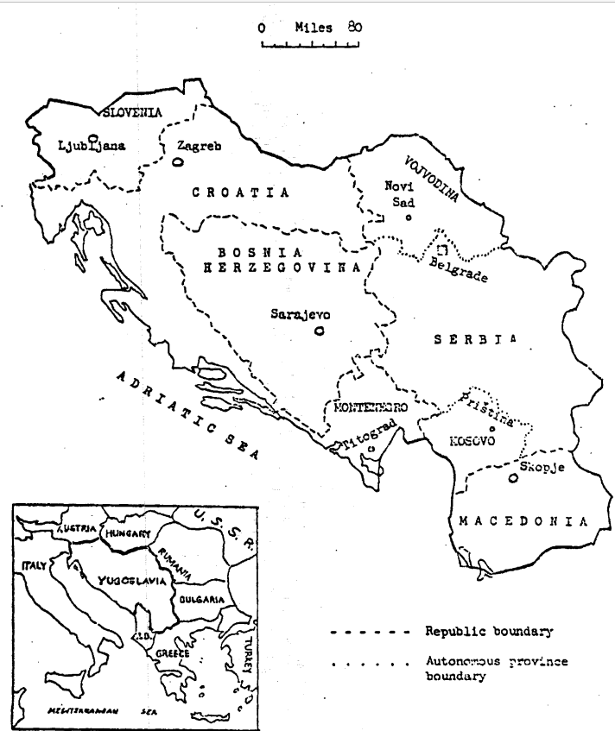

Self Management
The 1974 Constitution was built around a defining economic and political principle of Socialist “Self Management.” In simple terms, Self Management dictated that workers and peasants should own and control their own economic enterprises. This meant, for instance, that workers would oversee and operate state owned factories, electing Worker’s Councils of their peers to devise production plans and distribute surplus revenues with respect to market forces. This mixed-market approach stood in stark contrast to the centrally planned Socialist economies adopted by countries like the USSR, where factory management and activity was dictated by the highest echelons of the state. Yugoslavia’s theory of Self Management rose to prominence in the 1950s following the hostile political split between Tito and Joseph Stalin’s Eastern Bloc, which allowed and encouraged Yugoslavia to pave its own path forward. Having been partially elaborated in prior charters, one goal of the 1974 Constitution was to further affirm and develop Yugoslavia’s distinctive Self Management system vis-a-vis its institutions.
Politically speaking, Self Management sought to reconcile the existence of a central, one-party state with the ideal of working class self governance. If done successfully, such an arrangement would prevent the accumulation of power in an unrepresentative elite while simultaneously preserving an ideologically and politically cohesive government. The 1974 Constitution attempted, with difficulty, to manifest such a system. The result was an immensely complex apparatus of civil society groups, electoral colleges, and assemblies, extending from the lowest rung of the factory to the highest offices of the Federal government. To start, members of worker’s organizations, trade unions, veterans associations, activist groups, women’s leagues, and youth leagues, among other official constituencies, would elect local delegations on behalf of their communities. These delegations, acting as electoral colleges, would elect officials to communal assemblies. Then, the communal assemblies would appoint their own electoral delegations, who would, in turn, elect progressively higher positions in government. Assemblies were answerable to their appointers, observed term limits, and members could be recalled at will. Although it may appear unusual compared to a one-person one-vote system, the Self Management structure served as a representative mechanism that, in theory, prevented abuse of power and allowed the proletariat to govern themselves. Self Management also provided the basis for Yugoslavia’s continuously evolving federal structure. ⬩

Federal Structure
From its beginning, Tito’s Yugoslavia was arranged as a Federal Republic. This meant that political power was distributed between the national (a.k.a. the state, Federal, or central) Yugoslav government and the governments of six constituent Socialist Republics, plus two Socialist Autonomous Provinces (a.k.a. the regional governments). The lowest level of political organization was the Commune — oftentimes a single urban district or a grouping of dispersed rural villages. Per the Self Management system described above, each Commune held an elected communal assembly, which, through an electoral college, chose delegates to join their Republican or Provincial Assembly (the regional government) and the 220 member Federal Chamber (the lower house of the Federal Assembly, Yugoslavia’s national legislature). The Republican and Provincial Assemblies were in charge of regional affairs, and elected members indirectly to the 33 member Chamber of Republics and Provinces, the upper house of the Federal Assembly, and directly to the multi-member Federal Presidency.
The six constituent Republics of Yugoslavia were Serbia, Croatia, Slovenia, Macedonia, Montenegro, and Bosnia and Herzegovina, with the Federal capital in Belgrade, Serbia. The two Autonomous Provinces were Kosovo and Vojvodina, both territories of Serbia. Under the 1974 Constitution, the Republics and Provinces became the most prominent political units in the Federation. A significant degree of equal autonomy was granted to each region, and the two Provinces, although legally components of Serbia, were made politically on par with the six Republics. Under Yugoslavia’s representational system, each of the Republics and Provinces were given equal numbers of seats in the Federal Assembly, regardless of their population size (30 seats for each Republic and 20 for each Province in the Federal Chamber, and 12 seats for each Republic and 8 for each Province in the upper house). Unanimous agreement was required among the regional delegations before any legislation could be brought to the floor of the Federal Assembly, effectively granting every Republic and Province de facto veto power. Likewise, the Chamber of Republics and Provinces was required to consult directly with the individual Republican and Provincial level assemblies on pertinent national matters. Functionally, this meant that the Federal Assembly was less of a cohesive national legislature and more of a forum for bargaining, cooperation, and debate between the individual Republics and Provinces.
The principle of inter-Republican cooperation and mutual agreement, also called parity, was meant to ensure that all major decisions were founded on solidarity and consensus between the different Yugoslav peoples. However, the individual Republics and Provinces did not always agree. A mechanism was therefore required to break deadlock when disputes arose on the floor of the Assembly. Accordingly, the 1974 Constitution restructured the Executive branch into a 9-member office of the Presidency that could introduce legislation during stalemates and negotiate with regional Assemblies. One member was elected by each Republican and Provincial Assembly, and one seat was reserved for the President of the League of Communists, which was Tito until his death. A special lifetime office of the “President of the Republic” was also written into the new Constitution for Tito specifically, which would dissolve upon his passing. This position maintained most important Executive powers, such as direct command of the Army and security services and control over Federal organs, granting Tito a continued degree of central authority over Yugoslav affairs. To prepare for Tito’s passing, the Constitution stipulated that the 9-member Presidency would elect a President and Vice President from its members each year. Whoever had been elected Vice President at the time of Tito’s death would assume the office of President of the Presidency in his place, and the Presidency would collectively assume Tito’s responsibilities. The office would subsequently rotate between the different members, ensuring that Executive power would be evenly distributed between each of the Republics and Provinces.
There was a real anxiety that Tito’s continued commanding role as Executive could not be adequately filled by this arrangement after his death. An overreliance on his political presence had prevented Yugoslavia from developing a committed and capable cohort of national leadership to take his place, and the question of “succession” after Tito was hotly debated. In fact, just nine years after Tito’s death, the collective leadership system was exploited by Serbian nationalists, who occupied half of the seats in the Presidency and blocked the accession of the next President, inflaming tensions which ultimately led to Yugoslavia’s destruction. ⬩

Brotherhood and Unity
Like the Kingdom that came before it, the Socialist Federal Republic of Yugoslavia (SFRY) intended to unify the South Slavs under one national banner. “Brotherhood and Unity” became the defining motto of Tito’s Federation, entailing cooperation and peaceful coexistence between the different ethno-religious communities that lived together within its borders. Therefore, a central tenet of the 1974 Constitution was that of equal rights and stature for all of Yugoslavia’s constituent peoples. The Republics, acting as the principle units of political power for each community, were likewise defined as equal and sovereign nations under the terms of the Constitution. In essence, the six Republics were their own nation-states, bound together by a loose Federal center. Yet despite their sovereign status, expressions of regional nationalism within the Republics were strictly discouraged. During the Croatian Spring (1967-1971), for example, Croatian nationalists who had agitated for liberal reforms were purged from the ranks of the party at the behest of Tito. Nevertheless, the constitution was subsequently amended in a manner that gave the nationalists the heightened autonomy they had desired. Here we again see the perpetual and often paradoxical dichotomy of nationalism and centralism in Yugoslavia: power was devolved to the Republics, but their leaders were not to be Republicans. Rather, Tito hoped to foment a transcendent “Yugoslav” identity that surpassed all regional affiliations and grievances — yet grievances there remained.
Besides the traumas endured by different ethnic communities during the Second World War, a rift was present between the economically better developed “Northern” areas of Yugoslavia — namely, Slovenia and Croatia — and the lesser developed “South,” which included Bosnia, Serbia Proper, Macedonia, Montenegro, and Kosovo. This divide frequently inspired stalemates on the Assembly floor that escalated to full-blown national crises. In 1969, for example, the Slovenian government resigned in protest of a World Bank infrastructural loan that aided the other regions. Likewise, Croatia and Slovenia routinely protested development projects in the South that were subsidized by tourism revenues and other funds coming from the North. Many scholars agree that economic grievances inspired inflammatory nationalist politics within the Republics, which were given a platform by Yugoslavia’s Federal arrangement. In other words, although the 1974 Constitution was meant to promote cooperation between Yugoslavia’s constituent nations, it functionally legitimized the Republic as a basis for inter-ethnic differentiation, comparison, and competition.
This matter was further complicated by Yugoslavia’s demographic realities. In truth, none of the Republics besides Slovenia were ethnically homogeneous nation-states in the traditional sense. Yugoslavia’s various national groups were, in fact, dispersed throughout the Republics and Provinces in intermingled but unassimilated communities, as opposed to compact and congruent ethnic settlements. Additionally, Yugoslavia’s ethnic populations were not equal in size. In some cases, officially recognized minorities, such as Kosovar Albanians, were given less national political say than Slavic communities whom they outnumbered. These realities gave way to conflict when the majority and minority groups in a particular region felt that their sovereignty was not being appropriately respected. Such was the case historically between the Croat majority and Serb minority in Croatia, the Serb majority and Albanian minority in Serbia (and, respectively, the Albanian majority and Serb minority in Kosovo), and the Muslim plurality and the Serb and Croat minorities in Bosnia-Herzegovina, to name a handful. By and large, Tito managed to contain these disputes during his rule, but delicate questions concerning ethnic sovereignty and demographic differences remained to be fully answered. ⬩

Self-Reported Ethnic Composition of Yugoslavia, 1971
Group | % National Population | Total Population
Serbs | 39.7% | 8,143,246
Croats | 22.1% | 4,526,782
Muslims | 8.4% | 1,729,932
Slovenes | 8.2% | 1,678,032
Albanians | 6.4% | 1,309,523
Macedonians | 5.8% | 1,194,784
Montenegrins | 2.5% | 508,843
Hungarians | 2.3% | 477,374
Yugoslavs | 1.3% | 273,077

Regional Populations of Yugoslavia, 1971
Entity |  | % National Pop. | Total Pop.
SFR Yugoslavia |  | — | 20,523,000
Serbia | Total | 41% | 8,447,000
 | Serb. Proper | 26% | 5,250,000
 | Vojvodina | 10% | 1,953,000
 | Kosovo | 6% | 1,244,000
Croatia |  | 22% | 4,426,000
Bosnia |  | 18% | 3,746,000
Slovenia |  | 8% | 1,727,000
Macedonia |  | 8% | 1,647,000
Montenegro |  | 3% | 530,000

Role of the Communist Party
Yugoslavia was a one-party state, and the League of Communists was the sole legitimate political party. Membership in the League was a prerequisite for political officeship, and the League itself played an important role in the selection of delegates to the Federal Chamber (lists of eligible delegates were drawn up by the Socialist Alliance, a mass organization headed by the League). The League initially acted as a unified national party on the basis of “democratic centralism,” a philosophy which decreed that no members could oppose a decision by the party once it had been decided. Like any political party, the League was responsible for devising national political and economic policy, for developing Yugoslavia’s Socialist system and ideological doctrine, and for personnel appointments within the party ranks. Party membership in Yugoslavia was exclusive, and one could only become a member with the approval of the party itself. However, it was not as restrictive as other Communist parties at the time. It was not uncommon for regular laypersons to become politically active cadres in the League.
Like the Federation it commanded, the League of Communists consisted of a complex and convoluted apparatus of different organs, offices, and decision making bodies that were continuously decentralized throughout the 1960s and 1970s. The most significant change by 1974 was the devolution of party power to the Republican and Provincial level, where regional party apparatuses became the leading voices for policy and ideological decisions. Following the Ninth Party Congress, the principle of democratic centralism was slacked, party membership was expanded, and certain rules and procedures which promoted ideological cohesion were abandoned. Though Yugoslavia remained a single party state, the six Republican and two Provincial Leagues of Communists increasingly resembled individual parties with independent aims and interests. The national party, the League of Communists of Yugoslavia, which was led by a presidium and an Executive Bureau, began to act as a forum for inter-Republic bargaining rather than a source of united leadership, much like the Federal government had. Still, some central authority was retained in the national party, which held continued sway over personnel decisions in the regional Leagues and national economic policy. The wider role of the LCY in Yugoslav society, however, was becoming less and less clear. ⬩

List of Delegations

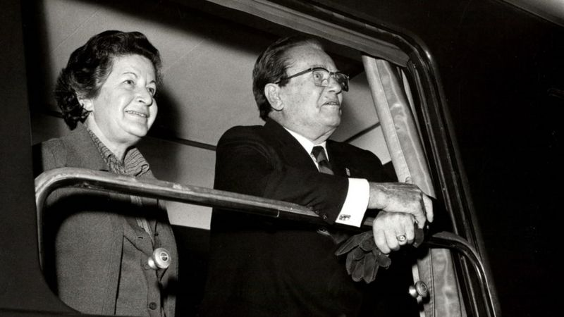

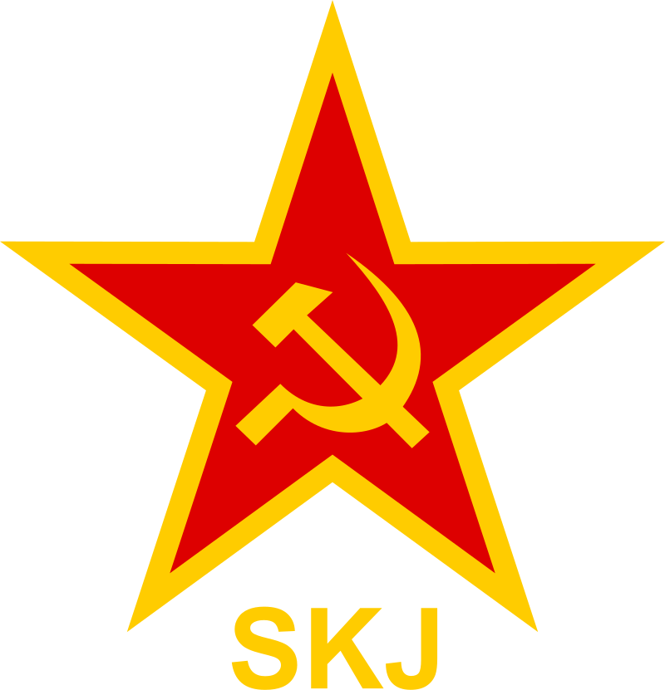
League of Communists of Yugoslavia
Over the past few decades, the Federal branch of the Communist Party, the League of Communists of Yugoslavia (LCY), has had its political power and importance diminished and supplanted by the Republican and Provincial Leagues. These developments have been furthered by the latest Constitution, which, by prioritizing inter-Republican consensus, has also given more credence to the regional level parties over the center. Those at the top, namely Tito and his inner circle of old allies, remain committed to the idea of a united national Communist Party, despite the ongoing federalization of the government. Several attempts have been made to recement the leading role and cohesion of the Federal LCY prior to the Tenth Congress, such as the creation of an LCY Executive Bureau to supersede the existing Party Presidency. The Executive Bureau was intended to act as a central backbone for the Federation as a whole, providing a comprehensive apparatus for unified national leadership stemming from the party.
In this committee, the delegation of the LCY will represent individuals at the party center who have acted as Tito’s traditional allies. They will need to strike a careful balance between the ongoing federalization of Yugoslavia’s political structure and the maintenance of a cohesive central authority. With the failure of the Executive Bureau to maintain a strong party center, it remains their priority to reassert the national leadership role and ideological importance formerly occupied by the LCY. Yet as long as the Federation continues to decentralize, it will be nearly impossible for the LCY to find its former place at the helm.
The following three individuals will represent the LCY in this committee:
Stane Dolanc, Slovenian and twice Secretary of the LCY Executive Bureau;
Vladimir Bakaric, Croatian member of the SFRY Presidency and LCY Bureau;
Cvijetin Mijatovic, Bosnian member of the SFRY Presidency and Tito’s close personal ally.

Yugoslav People’s Army
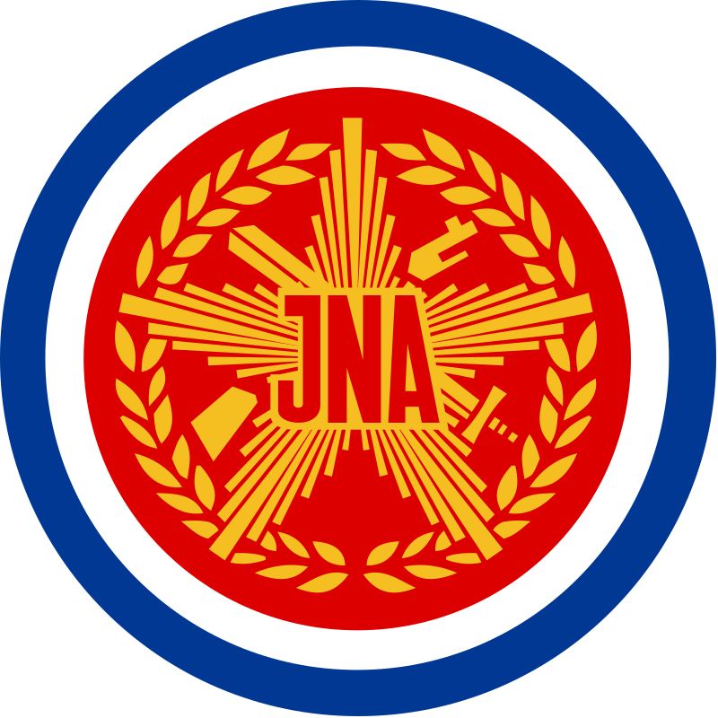
The Yugoslav People’s Army (JNA) is the national military force of Yugoslavia. As an institution, the JNA has played an important role in domestic political affairs and within the League of Communists. In fact, the political participation of the military has been so significant that the JNA has been compared to a “ninth province” on par with Yugoslavia’s eight regions. Historically, the People’s Army has intervened to resolve political crises, put down internal dissent, and enforce Communist party doctrine, acting as the physical arm of the Yugoslav state. Each of the Republics and Provinces also maintain their own, individual army reserves, known as the Territorial Defense (TO), comparable to the National Guard in the United States. The Territorial Defense forces are independent from the JNA, but can come under the same command in times of war.
Despite the overarching current of state decentralization, certain changes in the 1974 Constitution were welcomed by the JNA. These included the strengthening of the state Presidency and the simplification of the army command structure, which vested the Defense Minister with full control of both the JNA and the TO. Only the President of the Republic, the special executive position occupied exclusively by Tito and contingent on his longevity, surpasses the Defense Minister as supreme commander of the army. Since the army is a national institution, its leadership continues to support “the maintenance of a strong central authority” at the helm of the Federation and the JNA.
The following three individuals will represent the JNA in this committee:
Stane Potocar, Chief of the General Staff of the Yugoslav People’s Army;
Nikola Ljubicic, Minister of Defense of Yugoslavia;
Branko Mamula, Admiral of the Fleet of Yugoslavia.

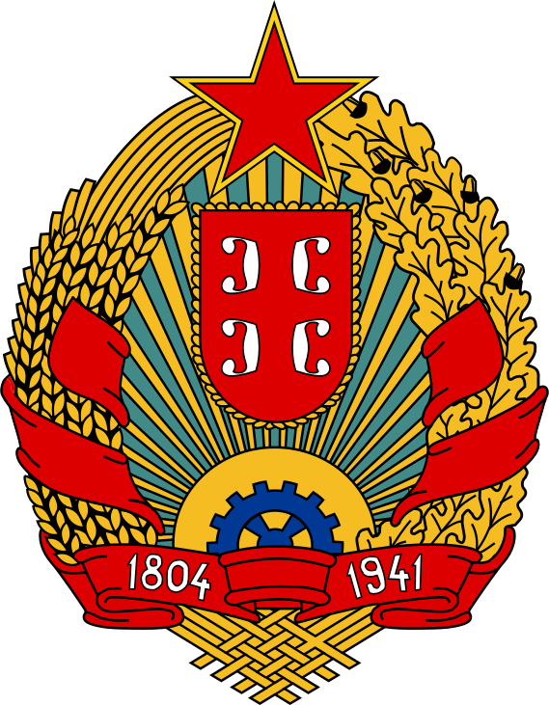
Socialist Republic of Serbia
The Socialist Republic of Serbia is the largest Republic, comprising roughly 41% of Yugoslavia’s overall population, and it occupies a unique position in the Federation at large. The politics of the first Yugoslavia was traditionally dominated by Serbia, and Tito’s construction of the Federation partly included an effort to cut Serbia “down to size.” Accordingly, Macedonia was severed from Serbia and recognized as its own sovereign Republic, as was Montenegro. The regions of Kosovo in the south and Vojvodina in the North were also granted greater degrees of autonomy within Serbia (the remaining territories are referred to as “Serbia Proper.”) After 1974 Serbia began to resemble an asymmetrical Federation. Kosovo and Vojvodina, each with independent constitutions and assemblies, were given veto power in Serbian legislative matters, whereas Belgrade was denied the same participation in the assemblies of its provinces.
Serbia is still a dominant player in Yugoslav politics, providing a centralist counterbalance to the reformist tendencies in Slovenia and Croatia. The current Serbian Communist leadership was appointed with considerable difficulty following Tito’s removal of reformists Latinka Perovic and Marko Nikezic from the party helm. The main priority of the Serbian League of Communists (LCS) is to reassert Serbia’s former degree of control over Kosovo (where the party is being overtaken by Albanian nationalists) and Vojvodina, and to prevent further expansion of their Provincial rights. Likewise, as the largest Republic, Serbian interests are intertwined with the consolidation of a more centralized (and Serb dominated) Yugoslav state.
The following five individuals will represent the Serbian delegation in this committee:
Spiro Galovic, a Serb nationalist municipal Party official from Belgrade;
Dragoslav Markovic, the President of the multi-member Serbian presidency;
Tihomir Vlaskalic, Tito’s choice head of the League of Communists of Serbia;
Djordje Lazic, trade union official and post-purge Secretary of the LCS;
Dusan Ckrebic, Speaker of the Serbian National Assembly.

Socialist Autonomous Province of Vojvodina
Vojvodina is one of two Socialist Autonomous Provinces of Serbia, the other being Kosovo. Vojvodina owes its special status to its history as an autonomous region of Austria-Hungary before WWI. Accordingly, as of the 1974 reforms, Vojvodina possesses its own constitution, regional assembly, and provincial League of Communists, and sends delegates to the collective Yugoslav Presidency and the Federal Assembly (albeit less in number than the Socialist Republics are afforded) where it has the same veto power as the other regions. These advances have led Vojvodina to be referred to as a quasi (semi) Republic. Vojvodina is still a legal constituency of Serbia and sends delegates to the Serbian assembly, but the League of Communists of Vojvodina (LCV) continues to agitate for an expanded degree of autonomy beyond that which is de jure afforded by the 1974 Constitution. A recent party purge was unsuccessful in its aim to promote centralist tendencies within the LCV.
In terms of geography and demographics, Vojvodina is “‘closer’ to Belgrade” than its counterpart Kosovo. Besides a notable Hungarian minority, most of Vojvodina’s inhabitants and political officials are ethnic Serbs. This may explain why Vojvodina’s leadership has felt more comfortable confronting Belgrade through open and direct political channels, even when their goals are contradictory. In fact, the predominant interests of the LCV lie not in Belgrade but with the Albanian controlled party in Kosovo. Fiercely defending Kosovo’s Provincial rights has given Vojvodina an avenue to protect its own. Therefore, maintaining, if not expanding, the semi-Republican prerogative of Vojvodina and its Kosovan ally remains the LCV’s main priority.
The following three individuals will represent Vojvodina in this committee:
Dusan Alimpic, President of the LCV, appointed following a party purge;
Nandor Major, writer, party cadre, and Secretary of the LCV;
Bosko Krunic, hardline Vojvodina Serb who later succeeds the LCV Presidency.

Socialist Autonomous Province of Kosovo
Kosovo is one of two Socialist Autonomous Provinces of Serbia, the other being Vojvodina. The constitutional status of Kosovo within Serbia has been the subject of tense debate since it was annexed from the Ottoman Empire in 1912. As of the 1974 reforms, Kosovo enjoys the same semi-Republican status as Vojvodina, possessing its own constitution, regional assembly, and provincial League of Communists. Kosovo also sends delegates to the collective Yugoslav Presidency and the Federal Assembly (albeit less in number than the Socialist Republics are afforded) where it has the same veto power as the other regions. Kosovo is still a legal constituency of Serbia and sends delegates to the Serbian assembly, but the League of Communists of Kosovo (LCK) continues to agitate for an expanded degree of autonomy beyond that which is de jure afforded by the 1974 Constitution.
Kosovo is far removed from Belgrade geographically, demographically, and politically. The majority of Kosovo’s population are ethnically Albanian, with a prominent and powerful Serb minority. Since 1971, the LCK leadership has been taken over by resolute Albanian nationalists, intent on separating Kosovo from Serbia and becoming its own Republic. After all, Kosovo’s population is more than double that of Montenegro, yet it enjoys less representation nationally. The result has been a campaign of Albanization within the party as the LCK attempts to isolate itself as much as possible from the League of Communists of Serbia. Preferring to go “its own way,” the LCK has severed formal coordination with the authorities in Belgrade while it attempts to expand and consolidate its prerogative in Kosovo. However, Kosovo will have to rely on help from Vojvodina if it wishes to withstand pushback from Serbia Proper.
The following three individuals will represent the Kosovan Delegation in this committee:
Dusan Ristic, Kosovo Serb and newly elected Secretary of the LCK;
Mehmut Bakali, hardline Kosovo Albanian and President of the LCK;
Sinan Hasani, Kosovo Albanian and Deputy Speaker of the Federal Assembly.

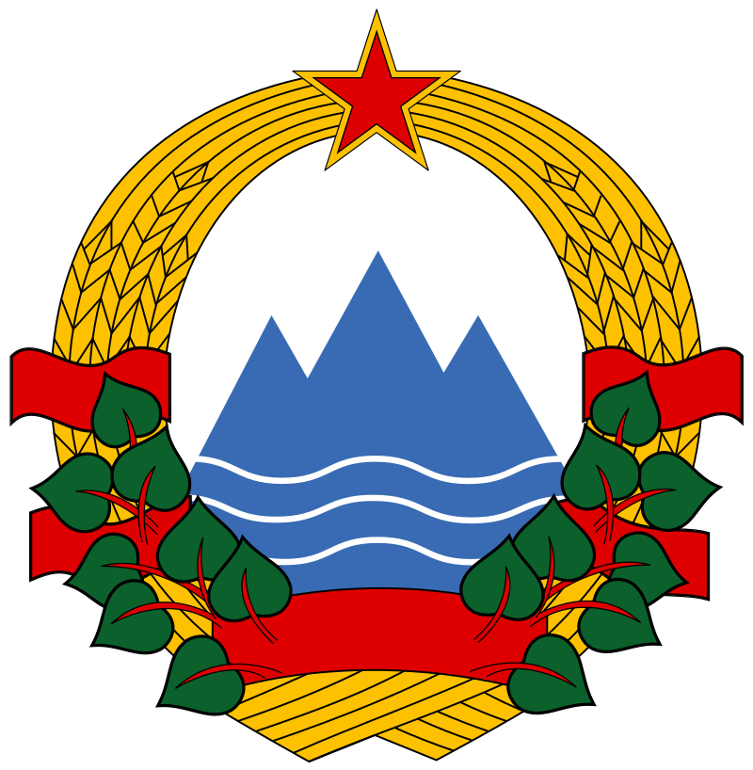
Socialist Republic of Slovenia
The Socialist Republic of Slovenia is one of Yugoslavia’s smaller Republics, comprising only 8% of the national population, yet it is one of the most economically prosperous. Alongside Croatia, Slovenia attracts a significant amount of foreign capital through tourism. Also like its neighbor, Slovenenians are primarily Catholic, and religion has played a notable role in Slovenian political discourse. During the 1960s, a wave of religious nationalism and Slovenian separatism was espoused by the Slovene intelligentsia, culminating in a crackdown by the League of Communists of Slovenia (ZKS). The status of faith and the political rights of worshippers within the Communist apparatus have also been debated within the ZKS for many years. Although religious freedom was guaranteed by the 1974 Constitution, believers are generally discriminated against and their political participation in the party is limited, begging questions about the structure of the Self Management system.
Though the ZKS leadership has suppressed nationalist and separatist sentiments regionally, it still seeks to promote Slovenia’s autonomy and economic interests within the Federation. Liberal economic reform, decreased state control, and an emphasis on market forces have been traditional positions for the ZKS leadership, and the party continues to oppose centralism at large. Additionally, there is an overriding feeling in Slovenia that it contributes more economically to the Federation that it receives, often supplying hard currency to the central government and instituting asymmetrical reforms only to be left out of Federal development projects. As a homogenous and potentially self-sufficient Republic, issues of Slovenia’s economic rights will have to be addressed, lest separatists take control once more.
The following five individuals will represent the Slovenian delegation in this committee:
Marijan Brecelj, Christian Socialist and Speaker of the Slovenian Assembly;
France Popit, hardline anti-centralist President of the ZKS;
Milan Kucan, reformist President of the Socialist Alliance (SAWP) of Slovenia;
Viktor Avbelj, economist and member of the ZKS Executive Council;
Franc Setinc, prolific author and Secretary of the ZKS.

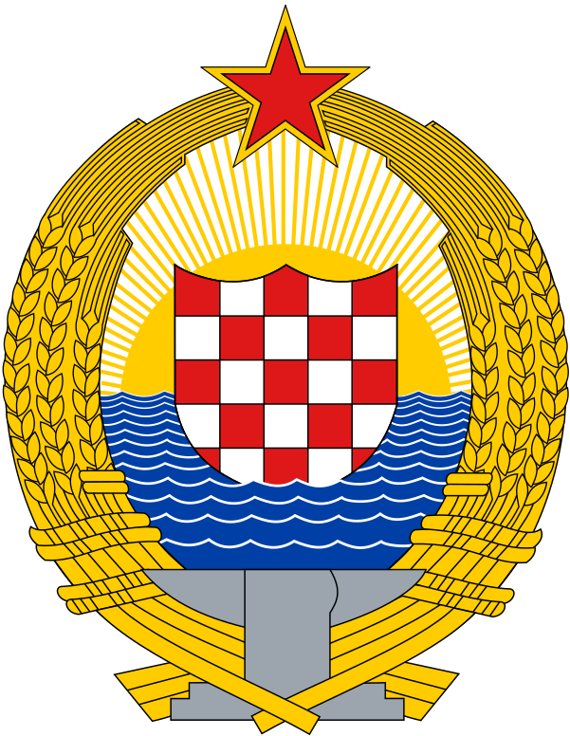
Socialist Republic of Croatia
The Socialist Republic of Croatia is the second largest Republic in Yugoslavia and one of the most politically prominent. Comprising about 22% of the overall population, the crescent shaped Republic is home primarily to ethnic Croats and a significant Serb minority, occupying 80% and 15% of the population respectively. For many years, the status of Croatia within the SFRY has inspired debate over the structure of the Yugoslav state at large. During the 1960s, for instance, a schism erupted in the League of Communists of Croatia (LCC) over the region’s perceived lack of sovereignty. The so-called Croatian Spring soon evolved into a national crisis, as liberals within the LCC demanded federal reforms in areas such as banking, foreign trade, and recognition of Croatian as a unique language. The dissenters were eventually ousted from the party with help from Tito and the LCY, but the Spring ultimately prompted a reassessment of the Yugoslav system, leading, in part, to the ratification of the 1974 Constitution.
The post-purge LCC leadership is much more unified than that of the 1960s and early 70s, and continues to agitate for Croatian economic and political prerogatives. Currents of nationalism and Serb dissent within Croatia have been suppressed by the LCC while it attempts to consolidate its control over the Republic. Meanwhile, the LCC persistently advocates for the “partial” interests of Yugoslavia’s regions against the Federal center. As part of Yugoslavia’s economically developed North, Croatia brings in a significant amount of foreign currency to the Yugoslav market. Therefore, it is Croatia’s best interest to implement liberal economic reforms that strengthen the fiscal rights of the Republics and the powers of regional political elites.
The following five individuals will represent the Croatian delegation in this committee:
Dusan Dragosavac, Croatian Serb and Secretary of the LCC;
Milka Planinc, post-purge President of the LCC;
Jure Bilic, anti-nationalist member of the LCY Executive Committee;
Marijan Kalanj, LCC Presidency member and trade union official;
Josip Vrhovec, member of the LCY Presidency and Executive Committee.

Socialist Republic of Bosnia and Herzegovina
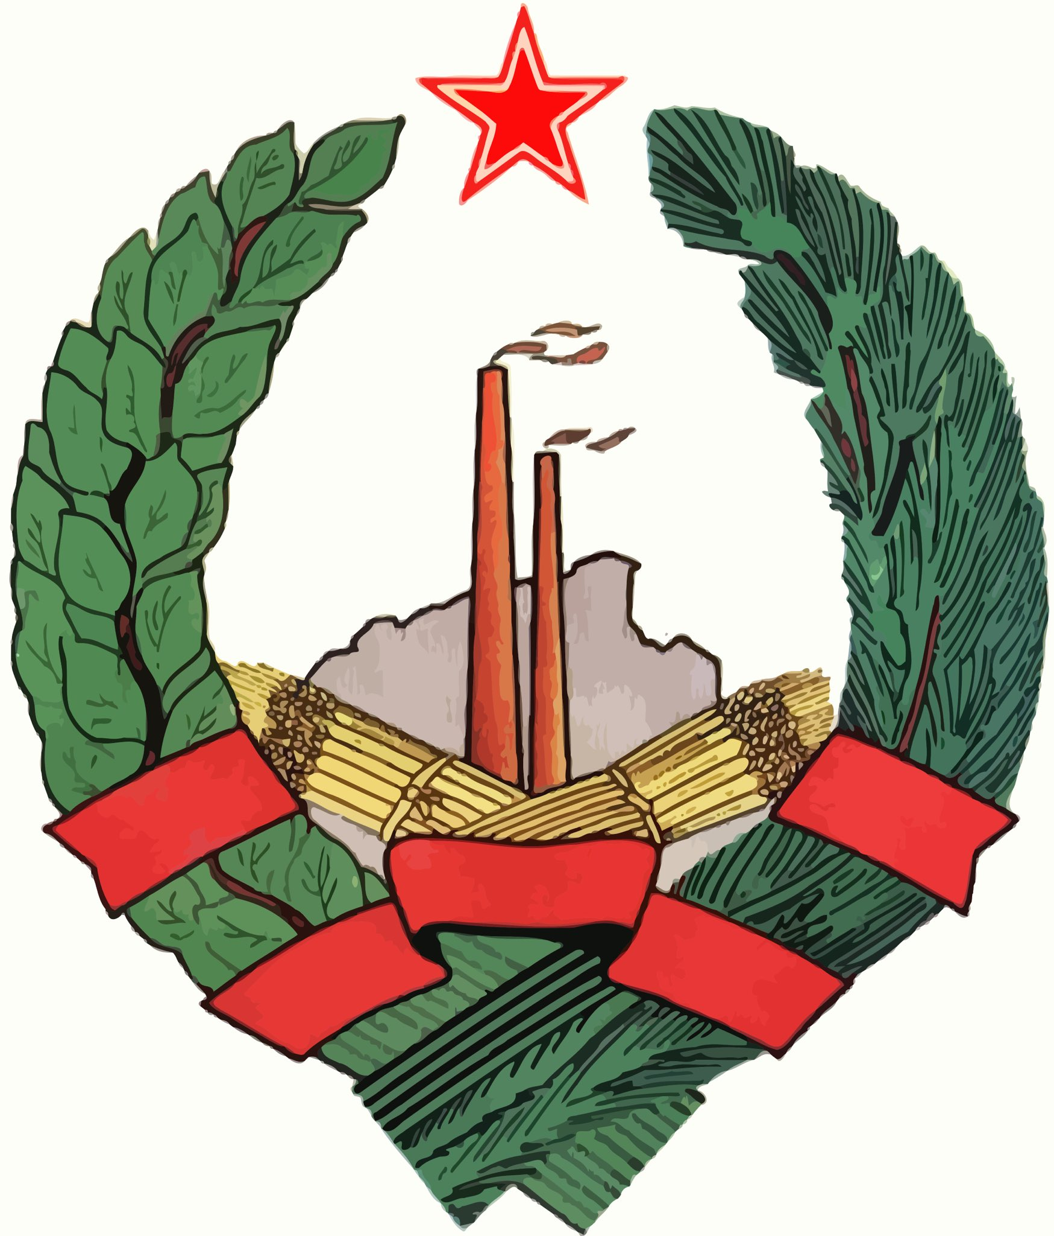
The Socialist Republic of Bosnia and Herzegovina is the third largest Republic, comprising 18% (nearly one fifth) of the Federation’s overall population. The demographic makeup of Bosnia is particularly notable. As of 1971, roughly 21% of Bosnians are ethnic Croats, 37% are ethnic Serbs, 40% are ethnic Muslims (Bosniaks) and around 3% identify as none or other. In this sense, Bosnia resembles a “Yugoslavia in miniature,” home to various intermingled ethno-religious communities living side by side in a cultural mosaic. Yet a distinct Bosnian national identity of its own has taken shape over the past few decades, most evidently in the movement by Bosnian Muslims to be recognized as a constituent national group, distinct from and coequal to Yugoslavia’s various other national communities. This recognition was affirmed by the 1974 Constitution, and Bosnia has become not only a Yugoslav Republic but a national homeland for the growing population of Bosniak people.
Bosnia occupies Yugoslavia’s political “periphery” with Vojvodina and Macedonia, who are often overshadowed by the more prominent leadership of Serbia and Croatia. Over the past decade, efforts have been undertaken to promote Bosnia as a counterweight to Belgrade and Zagreb, and to emphasize its own independent voice on national issues, as well as the needs of the smaller regions. For instance, despite ethnic similarity, Bosnian Serb officials have not been keen to ally with Serbia and are intent on defending the prerogatives of their own Republic. Overall, the current federalization of Yugoslavia suits Bosnia’s interests. However, the newest generation of the League of Communists of Bosnia (LCB), which was spared from Tito’s most recent party purges, must be cautious. Distributing further political power to the so-called periphery may encourage communities inside of Bosnia to pursue their own sovereignty, much like the Albanians in Kosovo. Therefore, Bosnia’s delegation must strike a careful balance between condemning nationalism federally while protecting Bosnia’s equal status and national sovereignty amidst the other Republics.
The following five individuals will represent the Bosnian delegation in this committee:
Hamdija Pozderac, Muslim nationalist and Speaker of the Bosnian Assembly;
Branko Mikulic, Bosnian Croat and pro-Constitution Secretary of the LCB;
Ratomir Dugonjic, President of the multi-member Presidency of Bosnia;
Milanko Renovica, Bosnian Serb President of the Bosnian Executive Council;
Dzemal Bijedic, Bosniak President of the Federal Executive Council.

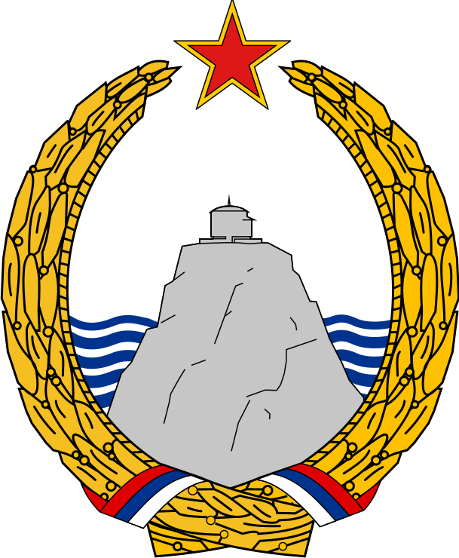
Socialist Republic of Montenegro
The Socialist Republic of Montenegro is the smallest Republic in Yugoslavia, accounting for merely 3% of the national population — twice as small as Kosovo and over three times smaller than Vojvodina, each of whom are given less representation in Federal affairs. Approximately 67% of the Republic’s inhabitants identify as ethnic Montenegrins, while the remainder mostly consist of Bosniaks, Albanians, and Serbs. Montenegro’s size means that it is the most disproportionately represented constituency in Yugoslav affairs, as per the provisions of the 1974 Constitution. Additionally, as part of Yugoslavia’s South, Montenegro benefits from industrial development projects and Federal subsidies funded by larger and more prosperous regions than its own.
Seemingly, Montenegro has the most to lose if the 1974 system were altered, yet voices from its leadership have occasionally raised interesting challenges to the longstanding political order. Members of the League of Communists of Montenegro (SKCG) and the regional Socialist Alliance have questioned democratic centralism, have advocated for a multi-party system, and have complied with Federal efforts to recentralize the state and party structures. Nevertheless, voices within the SKCG have failed to arouse the same degree of dissention as those within other regional Leagues. The SKCG was spared from Tito’s latest purges, leaving prior pro-Republican leaders at the helm, and the rank and file remain largely cohesive. Ultimately, Montenegro’s delegation will have to carefully consider its position as the smallest region, relying on Republican prerogatives as well as support from a strong central government.
The following five individuals will represent Montenegro’s delegation in this committee:
Budislav Soskic, Speaker of the Assembly of Montenegro;
Veljko Vlahovic, Tito ally, centralist, and member of the LCY Executive Bureau;
Vidoje Zarkovic, member of the SFRY Presidency for Montenegro;
Veselin Duranovic, President of the League of Communists of Montenegro;
Veljko Milatovic, President of the multi-member Presidency of Montenegro.

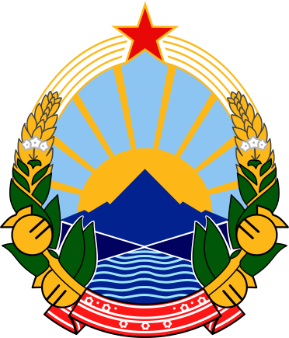
Socialist Republic of Macedonia
The Socialist Republic of Macedonia is one of the smallest and lesser developed regions in Yugoslavia, with a population only slightly smaller than that of Slovenia. Macedonia is also incredibly diverse: as of 1971, about 69% of the population are Macedonians, 17% are Albanians, 7% are Turks, 1.5% are Romani, and the remaining roughly 5% are an array of Serbs, Croats, Montenegrins, Muslims, and others. In fact, the acquisition of an official Macedonian national identity and recognition for the Macedonian language have been relatively recent victories. Under the first Yugoslavia, Macedonia was a territory of Southern Serbia; it was not until after the Second World War that the concept of a Macedonian nation was constitutionally affirmed. Therefore, as a constituency of the SFRY, maintaining regional sovereignty and equal rights among the Slavic nations remains a priority.
As such, the League of Communists of Macedonia (SKM) have been staunch defenders of decentralization, demanding both the federalization of the state as well as the Communist Party apparatus. In the view of the SKM, democratic centralism should require that no national policy decision be enacted if even one constituent nation finds it unfavorable. Similarly, the SKM believes that the regional Leagues should promote the individual interests of their respective nations. Principles of equal representation, unanimous consent, and veto power among the Republics have been particularly important principles to the SKM. Despite undergoing recent purges, the Macedonian leadership remains committed to their national prerogative and, as part of the political “periphery,” they hope to achieve equilibrium with more vocal regions.
The following five individuals will represent Macedonia in this committee:
Angel Cemerski, Secretary of the League of Communists of Macedonia;
Kiro Gligorov, reformist economist and member of the LCY Presidency;
Lazar Kolisevski, Tito’s wartime lieutenant and President of the SKM;
Krste Crvenkovski, anti-centralist cadre of the SKM who avoided Tito’s purge;
Vidoe Smilevski, pro-federal and pro-Yugoslav President of the multi-member Macedonian Presidency.

Questions to Consider
Debate in this committee will be heavily delegate driven, and students are encouraged to bring whatever topics, questions, and policy ideas to the table that they find most compelling. After carefully and critically assessing the information in this background guide, students should openly and honestly discuss the Yugoslav system, taking their own interpretations and their best understanding of the position they were assigned into account. As a student, please remember that you are not representing yourself, but the interests of your assigned character and delegation as they would have been in 1974. In order to get you started and to provide some helpful structure to debate, we have outlined some important questions for your consideration below. They are presented here based on the four subsections of the topic, as written in this guide. Make sure to jot these questions down and attempt to address at least some or all of them in your final draft resolution!

Questions: Self Management
- How can the Yugoslav system best represent the needs of the working class?
- Which interest groups and organizations should be able to participate in the delegate system, and what should this system look like?

Questions: Federal Structure
- How should the Federal government be structured? Who gets representation, and how much? How are decisions made, and which body gets to make them?
- What rights and responsibilities do Republics have compared to Provinces and the Federal government? Consider economic, military, civil, etc. Who gets to be a Republic vs. a Province?
- How should national power be shared? Should the government be more or less centralized? In what ways? What arrangements should be made for Tito’s death?

Questions: Brotherhood and Unity
- How can the interests of each Republic be protected without creating conflict?
- How can national sovereignty and autonomy be maintained for individual ethnic groups? Should nationalism be promoted or curtailed, and how?

Questions: Role of the Communist Party
- What role should the League of Communists play in Yugoslav public life? What are its roles and responsibilities in government and civil society? Who can join?
- Should the Party be centralized? In other words, should the Party center obey the regional Leagues, or vice versa? How can this be achieved?

Suggestions for Further Research
Due to the complex nature of this topic, students are not expected to consult sources beyond this background guide. For those interested, however, we recommend the following short documentary by The Cold War on Youtube, which presents a great summation of Yugoslav politics leading up to our committee:

- Tito and Market Socialism - Cold War DOCUMENTARY

For students interested in doing further research, we recommend starting out by consulting online encyclopedias such as Wikipedia and Encyclopedia Britannica before moving on to Google Scholar and poking around available articles.

References
- Yugocar Adventure, “Guided Yugo Adventures,” https://yugocar-adventure.com/guided-yugo-adventures/ (accessed 18 November 2022).
- Lonely Planet, “St. Mark’s Church,” https://www.lonelyplanet.com/croatia/zagreb/attractions/st-mark-s-church/a/poi-sig/425175/358800 (accessed 18 November 2022).
- Peter Korchnak, “You go, you go, Yugo — Antonika Buntak (Podcast Episode 1),” Remembering Yugoslavia, 05 July, 2020, https://rememberingyugoslavia.com/podcast-antonija-buntak/.
- Joe Sacco, Safe Area Gorazde: The War in Eastern Bosnia, 1991-95, (Seattle: Fantagraphics Books, 2000), pp. 19.
- A. M. Rosenthal, “Yugoslavs Win Council Seat, 39-19; Illegal, Vishinsky Says,” The New York Times, 21 October 1949. https://timesmachine.nytimes.com/timesmachine/1949/10/21/84577687.html (retrieved 18 November 2022)
- Eurovision Song Contest, “Eurovision Archives,” page 2. https://eurovision.tv/history?search=&page=2 (accessed 18 November 2022)
- André Munro, “Non-Aligned Movement,” Encyclopedia Britannica, 30 May 2022. https://www.britannica.com/topic/Non-Aligned-Movement
- Alex Yannis, “World Cup Soccer to Start Thursday in West Germany With a New Format,” The New York Times, 09 June 1974. https://www.nytimes.com/1974/06/09/archives/world-cup-soccer-to-start-thursday-in-west-germany-with-a-new.html (retrieved 18 November 2022)
- Neil Amdur, “U.S. Five Takes Gold Medal, Trouncing Yugoslavia by 95-74,” The New York Times, 28 July 1976. https://www.nytimes.com/1976/07/28/archives/us-five-takes-gold-medal-trouncing-yugoslavia-by-9574-dantley.html (retrieved 18 November 2022)
- Robert W. Pringle, “Balkanization,” Encyclopedia Britannica, 09 April 2018, https://www.britannica.com/topic/Balkanization
- Dejan Jovic, “The Disintegration of Yugoslavia: A Critical Review of Explanatory Approaches,” European Journal of Social Theory, 4(1) (2001): 101-120. https://doi.org/10.1177/13684310122225037.
- Spadijer, Balsa. “Federalism and National Question in Socialist Yugoslavia.” The Indian Journal of Political Science 38, No. 4 (Oct.-Dec. ’77): 521-533.
- Roberts, Adam. “Yugoslavia: The Constitution and the Succession.” The World Today. Apr., 1978, Vol. 34, No. 4 (Apr., 1978): 136-146. Chatham House. https://www.jstor.org/stable/40395044
- The Cold War. “Tito and Market Socialism - Cold War DOCUMENTARY.” 10 December 2022. Video, 20:57. https://youtu.be/SJhwCtP-Tro (Accessed 16 December 2023).
- John B. Allock, “Yugoslavia,” Encyclopedia Britannica, 5 January 2023, https://www.britannica.com/place/Yugoslavia-former-federated-nation-1929-2003.
- Yugoslavia Secretariat of the Federal Assembly Information Service. The Constitution of the Socialist Federal Republic of Yugoslavia. Translated by Marko Pavicic. Ljubljana: Dopisna Delavska Univerza, 1974. https://www.worldstatesmen.org/Yugoslavia-Constitution1974.pdf (Accessed 10 January 2023).
- https://www.worldstatesmen.org/Yugoslavia-Constitution1974.pdf (Accessed 10 January 2023).
- Johnson, A. Ross. Political Leadership in Yugoslavia; Evolution of the League of Communists (U). Santa Monica: RAND Corporation, 1983. https://digitalarchive.wilsoncenter.org/document/ross-johnson-political-leadership-yugoslavia-evolution-league-communists-approved-release (Accessed 16 January 2023).
- Muntasir Mahmud Sium, “Ethnic Groups in Yugoslavia,” https://www.wikiwand.com/en/Ethnic_groups_in_Yugoslavia (Accessed 12 January 2023).
- CICRED, The Population of Yugoslavia (Belgrade: CICRED., 1974). http://www.cicred.org/Eng/Publications/pdf/c-c55.pdf
- Ramet, Pedro. “Political Struggle and Institutional Reorganization in Yugoslavia.” Political Science Quarterly Vol. 99, No. 2 (Summer, 1984): 289-301. https://www.jstor.org/stable/2150406
- Dyker, David A. and Ivan Vejvoda. Yugoslavia and After: A Study in Fragmentation, Despair and Rebirth. England: Routledge, 2014. Chapter 4.
- Ramsak, Jure. “Between ideology and pragmatism: polemic on the civil rights of Christians in the socialist Slovenia of the 1970s.” Religion, State and Society 43:2: 168-183. 43:2, 168-183. DOI: http://dx.doi.org/10.1080/09637494.2015.1053188.
- Carter, April. “The Republics and the Party.” Review of Conflict and Cohesion in Socialist Yugoslavia: Decision Making Since 1966 by Steven L. Burg. Government and Opposition Vol. 19, No. 3 (SUMMER 1984): 385-390. https://www.jstor.org/stable/44484272.
- Zaninovich, George M. “Leadership and Change in Yugoslavia.” Current History Vol. 80, No. 465, EAST EUROPE, 1981 (APRIL, 1981): 173-177,
- Kamberović, Husnija. “Between Muslimdom, Bosniandom, Yugoslavdom and Bosniakdom: The Political Elite in Bosnia and Herzegovina in the late 1960s and early 1970s,” in The Ambiguous Nation. Case Studies from Southeastern Europe in the 20th Century, edited by Ulf Brunnbauer and Hannes Grandits, 57-76. Munich: Oldenbourg Verlag, 2013.
- Franjo Maric, Pregled pučanstva Bosne i Hercegovine između 1879. i 1995. godine [Overview of the population of Bosnia and Herzegovina between 1879 and 1995], Zagreb, 1996.
- Statistical Office of Montenegro, via Wikipedia.
- Croatian Bureau of Statistics, “POPULATION BY ETHNICITY, 1971 — 2011 CENSUSES,” CIA, retrieved September 2016.

Dejan Jovic, “The Disintegration of Yugoslavia: A Critical Review of Explanatory Approaches,” European Journal of Social Theory, 4(1) (2001): 101-120. https://doi.org/10.1177/13684310122225037.
Sacco, Safe Area Gorazde.
Sacco, Safe Area Gorazde.
Sacco, Safe Area Gorazde.
Roberts, The Constitution and the Succession, 145.
Roberts, The Constitution and the Succession, 145.
Johnson, Political Leadership in Yugoslavia, 26.
Johnson, Political Leadership in Yugoslavia.
Johnson, Political Leadership in Yugoslavia.
Johnson, Political Leadership in Yugoslavia.
Johnson, Political Leadership in Yugoslavia.
Johnson, Political Leadership in Yugoslavia.
Johnson, Political Leadership in Yugoslavia; Roberts, The Constitution and the Succession.
Roberts, The Constitution and the Succession.
Secretariat of the Federal Assembly Information Service, The Constitution of the Socialist Federal Republic of Yugoslavia.
Johnson, Political Leadership in Yugoslavia; Roberts, The Constitution and the Succession.
CICRED, The Population of Yugoslavia
David A. Dyker and Ivan Vojvoda, Yugoslavia and After: A Study in Fragmentation, Despair and Rebirth, England: Routledge, 2014, Chapter 4.
Johnson, Political Leadership in Yugoslavia, p. viii.
Johnson, Political Leadership in Yugoslavia, p. viii.
Johnson, Political Leadership in Yugoslavia.
Johnson, Political Leadership in Yugoslavia.
Johnson, Political Leadership in Yugoslavia.
Johnson, Political Leadership in Yugoslavia.
Johnson, Political Leadership in Yugoslavia.
Johnson, Political Leadership in Yugoslavia.
Johnson, Political Leadership in Yugoslavia.
Johnson, Political Leadership in Yugoslavia, 59.
Johnson, Political Leadership in Yugoslavia.
Franjo Maric, Pregled pučanstva Bosne i Hercegovine između 1879. i 1995. godine [Overview of the population of Bosnia and Herzegovina between 1879 and 1995], Zagreb, 1996.
Ulf Brunnbauer and Hannes Grandits, ed., The Ambiguous Nation. Case Studies from Southeastern Europe in the 20th Century (Munich: Oldenbourg Verlag, 2013), 57.
Brunnbauer and Grandits, The Ambiguous Nation.
Brunnbauer and Grandits, The Ambiguous Nation; Johnson, Political Leadership in Yugoslavia.
Roberts, The Constitution and the Succession.
The Cold War, “Tito and Market Socialism.”
The Cold War, “Tito and Market Socialism.”
Roberts, The Constitution and the Succession.
Roberts, The Constitution and the Succession; Spadijer, “Federalism and National Question.”
Roberts, The Constitution and the Succession.
Yugoslavia Secretariat of the Federal Assembly Information Service, The Constitution of the Socialist Federal Republic of Yugoslavia, translated by Marko Pavicic. Ljubljana: Dopisna Delavska Univerza, 1974. https://www.worldstatesmen.org/Yugoslavia-Constitution1974.pdf (Accessed 10 January 2023).
Roberts, The Constitution and the Succession.
John B. Allock, “Yugoslavia,” Encyclopedia Britannica, 5 January 2023, https://www.britannica.com/place/Yugoslavia-former-federated-nation-1929-2003.
Spadijer, “Federalism and National Question.”
Spadijer, “Federalism and National Question.”
The Cold War, “Tito and Market Socialism - Cold War DOCUMENTARY,” 10 December 2022, Video, 20:57. https://youtu.be/SJhwCtP-Tro (Accessed 16 December 2023).
The Cold War, “Tito and Market Socialism.”
Roberts, The Constitution and the Succession; The Cold War, “Tito and Market Socialism.”
Roberts, The Constitution and the Succession.
Roberts, The Constitution and the Succession.
Muntasir Mahmud Sium, “Ethnic Groups in Yugoslavia,” https://www.wikiwand.com/en/Ethnic_groups_in_Yugoslavia (Accessed 12 January 2023).
Johnson, Political Leadership in Yugoslavia.
Johnson, Political Leadership in Yugoslavia.
Johnson, Political Leadership in Yugoslavia.
Sacco, Safe Area Gorazde.
Roberts, The Constitution and the Succession.
The Cold War, “Tito and Market Socialism.”
Roberts, The Constitution and the Succession.
Pedro Ramet, “Political Struggle and Institutional Reorganization in Yugoslavia,” Political Science Quarterly Vol. 99, No. 2 (Summer, 1984): 289-301. https://www.jstor.org/stable/2150406
Johnson, Political Leadership in Yugoslavia.
Ramet, “Political Struggle.”
Johnson, Political Leadership in Yugoslavia.
CICRED, The Population of Yugoslavia; Croatian Bureau of Statistics, “POPULATION BY ETHNICITY, 1971 — 2011 CENSUSES,” CIA, retrieved September 2016.
Johnson, Political Leadership in Yugoslavia, 25.
Johnson, Political Leadership in Yugoslavia.
The Cold War, “Tito and Market Socialism.”
Johnson, Political Leadership in Yugoslavia.
CICRED, The Population of Yugoslavia; Johnson, Political Leadership in Yugoslavia.
The Cold War, “Tito and Market Socialism.”
Johnson, Political Leadership in Yugoslavia.
Jure Ramsak, “Between ideology and pragmatism: polemic on the civil rights of Christians in the socialist Slovenia of the 1970s,” Religion, State and Society 43:2: 168-183. 43:2, 168-183. DOI: http://dx.doi.org/10.1080/09637494.2015.1053188.
Johnson, Political Leadership in Yugoslavia.
Ramsak, “Between ideology and pragmatism.”
CICRED, The Population of Yugoslavia.
Johnson, Political Leadership in Yugoslavia.
Brunnbauer and Grandits, The Ambiguous Nation.
Johnson, Political Leadership in Yugoslavia.
Johnson, Political Leadership in Yugoslavia.
Johnson, Political Leadership in Yugoslavia.
CICRED, The Population of Yugoslavia; Johnson, Political Leadership in Yugoslavia.
Statistical Office of Montenegro.
Johnson, Political Leadership in Yugoslavia.
Johnson, Political Leadership in Yugoslavia.
Johnson, Political Leadership in Yugoslavia; Ramet, “Political Struggle.”
Yugocar, “Guided Yugo Adventures,” under “Yugo & the City.”
Lonely Planet, “St. Mark’s Church,” https://www.lonelyplanet.com/croatia/zagreb/attractions/st-mark-s-church/a/poi-sig/425175/358800 (accessed 18 November 2022).
Peter Korchnak, “You go, you go, Yugo — Antonika Buntak (Podcast Episode 1),” Remembering Yugoslavia, 05 July, 2020, https://rememberingyugoslavia.com/podcast-antonija-buntak/.
Korchnak, “You go, you go Yugo.”
Joe Sacco, Safe Area Gorazde: The War in Eastern Bosnia, 1991-95, (Seattle: Fantagraphics Books, 2000), pp. 19.
Sacco, Safe Area Gorazde, pp. 19, also chap. “Disintegration,” pp. 36-43.
Robert W. Pringle, “Balkanization,” Encyclopedia Britannica, 09 April 2018, https://www.britannica.com/topic/Balkanization.
Balsa Spadijer, “Federalism and National Question in Socialist Yugoslavia,” The Indian Journal of Political Science, 38 no. 4 (1977): 521-533. http://www.jstor.org/stable/41854942.
Adam Roberts, “Yugoslavia: The Constitution and the Succession,” The World Today. Apr., 1978, Vol. 34, No. 4 (Apr., 1978): 145. Chatham House. https://www.jstor.org/stable/40395044
Yugocar Adventure, “Guided Yugo Adventures,” https://yugocar-adventure.com/guided-yugo-adventures/ (accessed 18 November 2022).
A. M. Rosenthal, “Yugoslavs Win Council Seat, 39-19; Illegal, Vishinsky Says,” The New York Times, 21 October 1949. https://timesmachine.nytimes.com/timesmachine/1949/10/21/84577687.html (retrieved 18 November 2022); Eurovision Song Contest, “Eurovision Archives,” page 2. https://eurovision.tv/history?search=&page=2 (accessed 18 November 2022); André Munro, “Non-Aligned Movement,” Encyclopedia Britannica, 30 May 2022. https://www.britannica.com/topic/Non-Aligned-Movement; Alex Yannis, “World Cup Soccer to Start Thursday in West Germany With a New Format,” The New York Times, 09 June 1974. https://www.nytimes.com/1974/06/09/archives/world-cup-soccer-to-start-thursday-in-west-germany-with-a-new.html (retrieved 18 November 2022); Neil Amdur, “U.S. Five Takes Gold Medal, Trouncing Yugoslavia by 95-74,” The New York Times, 28 July 1976. https://www.nytimes.com/1976/07/28/archives/us-five-takes-gold-medal-trouncing-yugoslavia-by-9574-dantley.html (retrieved 18 November 2022).
Sacco, Safe Area Gorazde.
Jovic, “The Disintegration of Yugoslavia.”
Sacco, Safe Area Gorazde.
Allock, “Yugoslavia.”
Secretariat of the Federal Assembly Information Service, The Constitution of the Socialist Federal Republic of Yugoslavia.
A. Ross Johnson, Political Leadership in Yugoslavia; Evolution of the League of Communists (U) (Santa Monica: RAND Corporation, 1983). https://digitalarchive.wilsoncenter.org/document/ross-johnson-political-leadership-yugoslavia-evolution-league-communists-approved-release (Accessed 16 January 2023).
Secretariat of the Federal Assembly Information Service, The Constitution of the Socialist Federal Republic of Yugoslavia.
Roberts, The Constitution and the Succession.
Roberts, The Constitution and the Succession.
Roberts, The Constitution and the Succession.
Sacco, Safe Area Gorazde.
Secretariat of the Federal Assembly Information Service, The Constitution of the Socialist Federal Republic of Yugoslavia.
Johnson, Political Leadership in Yugoslavia.
Johnson, Political Leadership in Yugoslavia.
Johnson, Political Leadership in Yugoslavia.
Spadijer, “Federalism and National Question.”
Sium, “Ethnic Groups.”
CICRED, The Population of Yugoslavia (Belgrade: CICRED., 1974). http://www.cicred.org/Eng/Publications/pdf/c-c55.pdf
Johnson, Political Leadership in Yugoslavia.
Brunnbauer and Grandits, The Ambiguous Nation; Johnson, Political Leadership in Yugoslavia.

